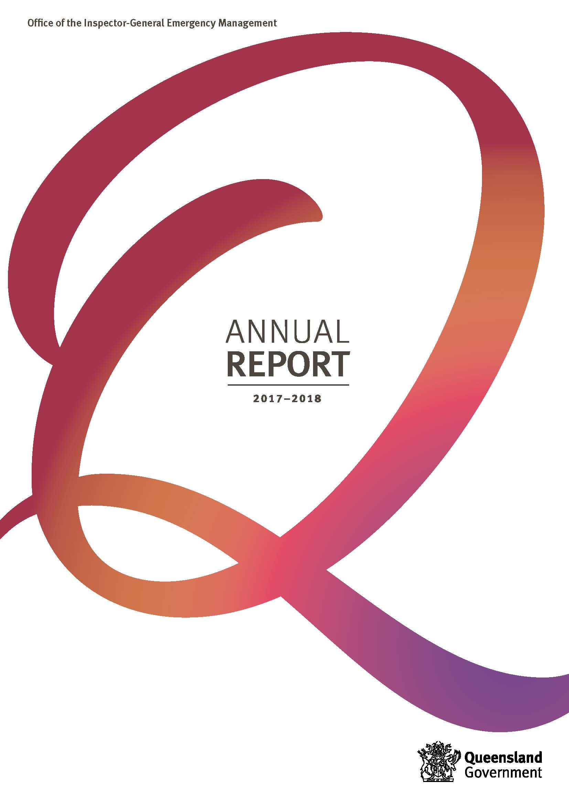

This annual report provides information about the Office of the Inspector-General Emergency Management financial and non-financial performance for 2017-18. It has been prepared in accordance with the Financial Accountability Act 2009, the Financial and Performance Management Standard 2009 and the Annual report requirements for Queensland Government agencies.
The annual report includes the significant achievements against the objectives and strategies detailed in the Office of the Inspector-General Emergency Management Strategic Plan 2017-21 and the Service Delivery Statement 2017-18.
For more information
Telephone: (07) 3029 8813
Visit: www.igem.qld.gov.au
Email: info@igem.qld.gov.au
This annual report is available on the Office of the Inspector-General Emergency Management website at www.igem.qld.gov.au/reports-and-publications/annual-reports/Pages/default.aspx or a paper copy can be provided on request by telephoning (07) 3029 8813.
Feedback
Feedback on the annual report can be provided through the Get Involved website:
www.qld.gov.au/annualreportfeedback
Acknowledgement of Country
The Office of the Inspector-General Emergency Management acknowledges traditional owners of lands across Queensland and pays respect to the Elders—past, present and emerging—for they hold the memories, traditions, the culture and hopes of Aboriginal and Torres Strait Islander peoples across the state.
Other languages and formats
The Queensland Government is committed to providing accessible services to Queenslanders from all culturally and linguistically diverse backgrounds. If you have difficulty understanding this report, you can access the Translating and Interpreting Service (TIS National) via www.qld.gov.au/languages or telephoning 13 14 50.

Copyright
© The State of Queensland (Office of the Inspector-General Emergency Management) 2018.
Published by the Queensland Government, September 2018. Level 26, 111 George Street, Brisbane Qld 4000.
Licence
This annual report is licensed by the State of Queensland (Office of the Inspector-General Emergency Management) under a Creative Commons Attribution (CC BY) 4.0 Australia licence.

CC BY Licence Summary Statement
In essence, you are free to copy, communicate and adapt this annual report, as long as you attribute the work to the State of Queensland (Office of the Inspector-General Emergency Management). To view a copy of this licence, visit: creativecommons.org/licenses/by/4.0
Attribution
Content from this annual report should be attributed to:
The State of Queensland (Office of the Inspector-General Emergency Management) Annual Report 2017-18.
ISSN:
Online: 2205-6548
Print: 2206-1444
Open data
Information about consultancies, overseas travel and the Queensland Language Services Policy is available at the Queensland Government Open Data website www.data.qld.gov.au
www.facebook.com/InspectorGeneralEmergencyManagement

Letter of Compliance

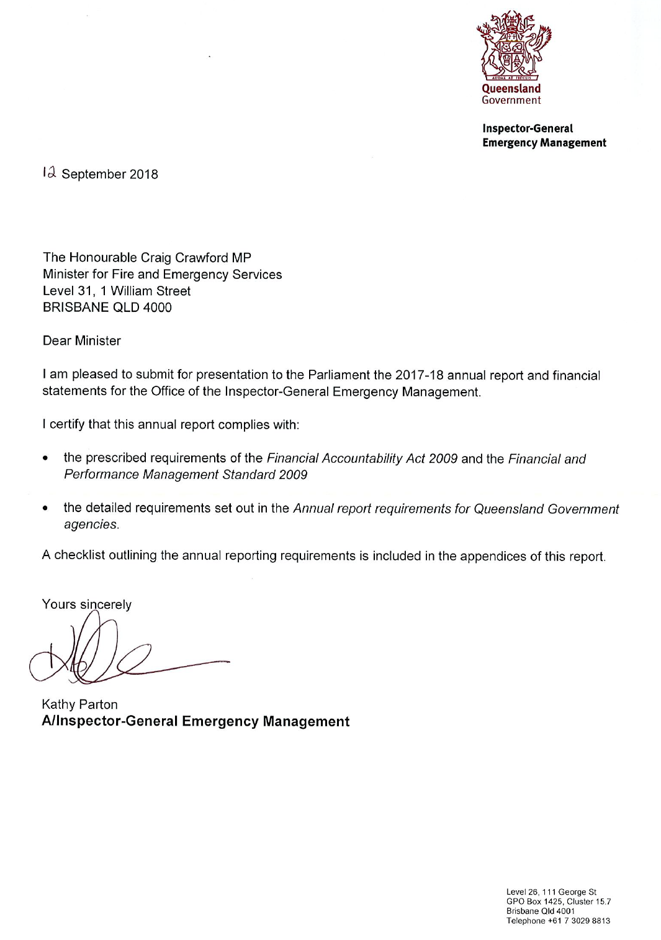

Table of contents

Table of contents 1
Inspector-General’s message 2
Overview 4
About us 4
Structure 9
Financial summary 10
Summary of financial performance 10
Summary of financial position 11
Performance 12
Key performance measures 12
2017-18 Highlights 14
Objective one 14
Objective two 18
Objective three 22
Governance 24
Executive management 24
Committees 26
Ethics and Code of Conduct 28
Risk management and accountability 29
Human resources 32
Financial statements – Table of Contents 35
Statement of comprehensive income 36
Statement of financial position 37
Statement of changes in equity 38
Statement of cash flows 39
Notes to and forming part of the financial statements 2017-18 40
Management certificate 51
Independent Auditor’s report 52
Appendices 55
Acronyms 55
Compliance checklist 57
Contacts and key locations 59

Inspector-General’s message
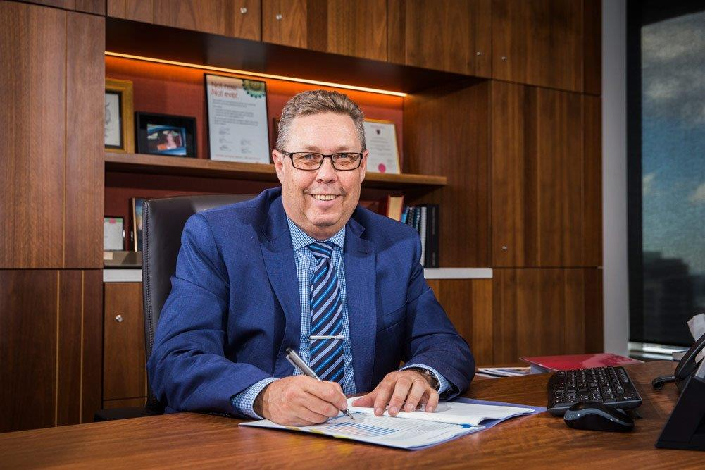
The Office of the Inspector-General Emergency Management (the Office) made significant progress during the 2017-18 financial year in delivering on its vision of being the catalyst for disaster management excellence in Queensland.
Through the ground-breaking Emergency Management Assurance Framework and Australia’s first Standard for Disaster Management, the Office undertook a comprehensive program of assurance activities and initiatives to support the development and maintenance of world class disaster management arrangements.
Inspector-General Iain MacKenzie
And consistent with an ongoing core value of the Office, ground-up consultation with stakeholders formed the foundation of how we approached and delivered our assurance activities throughout the year.
This collaborative approach was an instrumental component of reviews during 2017-18, which included:
- a review of disaster management arrangements associated with Tropical Cyclone Debbie. As part of the review, the Office was tasked to ensure good practice was identified; lessons learnt from the event were captured; and that common themes for improvement were adopted.
- the Townsville Capability Review, which assessed the ability of the Townsville District Disaster Management Group, and local disaster management groups in Richmond, Palm Island, Hinchinbrook, Flinders, Charters Towers, Burdekin and Townsville to meet future challenges, as measured against the Standard for Disaster Management in Queensland.
- a review of evacuation management arrangements, which assessed the extent to which arrangements and plans reflect good practice, the Standard for Disaster Management in Queensland, and the capacity to adapt plans to events.
Apart from reviews, the Office undertook a comprehensive range of other activities and initiatives during 2017-18 to further enhance disaster management excellence at the local, State and Federal levels. Achievements surrounding this work included:
- the development of the first draft of a Queensland-specific disaster management lexicon, to ensure consistency and common understanding of key words used within the sector
- the commencement of a system-wide lessons management program to enable improvement strategies and innovative solutions, good practice, and ideas to grow capability
- the development of a research framework to collaboratively develop and promote disaster management, specifically for the Queensland context
- winning the Leadership Category of the 2017 Premier’s Awards for Excellence for the Disaster Management Officers’ Network; the network now incorporates 91 staff from 55 councils
- securing formal White Ribbon accreditation as part of the Office’s active support and commitment to seeking to prevent violence against women
- commencement of a refresh of the ground-breaking Emergency Management Assurance Framework and Standard for Disaster Management in Queensland
- partnership with the Commonwealth and the coordination of Queensland’s involvement in the development of the Australian Vulnerability Profile, which seeks to better understand and mitigate risks nationally
- partnering with tertiary institutions on pivotal disaster management studies including community engagement and associated tools; the use of augmented and virtual reality; environmental recovery; and a needs analysis and good practice study regarding datasets used by practitioners
- leading, collaborating and presenting with key partners including Australian Fire and Emergency Services Authorities Council, Queensland University of Technology, Australian Institute of Police Management, Griffith University, Council on the Ageing, Australian Strategic Policy Institute, University of Queensland, and the Australian National University
- development of a contemporary disaster management analytics dashboard, in collaboration with the Department of Housing and Public Works, to allow enhanced analysis and sharing of data from annual disaster management plan assessments.
While much was achieved in driving disaster management excellence during the financial year, more work needs to be done, particularly in the area of lessons management.
Accordingly, my goal for the coming year is to expand on the excellent work of 2017-18 and continue to embrace close and collaborative working arrangements with stakeholders, to bring about real change and enhanced confidence in disaster management arrangements in Queensland.

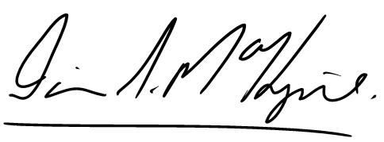
Iain S MacKenzie AFSM
Inspector-General Emergency Management

Overview

About us
Our vision
A catalyst for excellence in emergency management

Our purpose
To enable confidence in Queensland’s emergency management arrangements
The Office of the Inspector-General Emergency Management (the Office) was formally established as a public service office on 1 July 2014, under amendments to the Disaster Management Act 2003, to support confidence in Queensland’s emergency management arrangements.
The Office provides independent assurance and advice about Queensland’s emergency management arrangements, with a focus on a risk-based approach. It also provides authoritative reporting to enhance accountability and improve outcomes for the community.
The Office undertakes targeted reviews and system analysis to identify risks to emergency management planning, preparedness, response and recovery arrangements and recommends evidence-based improvements.
Disaster management within Queensland is built on local capability and capacity, supported and strengthened through a scalable, responsive model. The model builds on the availability and coordination of support at local, district, state and national levels. The success of the system relies on key stakeholders working together in collaborative and cooperative ways.
The Office delivers its services from Brisbane.

Our accountabilities
The Office has the following functions under the Disaster Management Act 2003:
- regularly review and assess the effectiveness of disaster management by the state, including the State Disaster Management Plan and its implementation
- regularly review and assess the effectiveness of disaster management by district and local groups, including district and local disaster management plans
- regularly review and assess cooperation between entities responsible for disaster management in the state, including whether the disaster management systems and procedures employed by those entities are compatible and consistent
- make disaster management standards
- regularly review and assess disaster management standards
- review, assess and report on performance by entities responsible for disaster management in the state against the disaster management standards
- work with entities performing emergency services, departments and the community to identify and improve disaster management capabilities, including volunteer capabilities
- monitor compliance by departments with their disaster management responsibilities
- identify opportunities for cooperative partnerships to improve disaster management outcomes
- report to, and advise, the Minister about issues relating to the abovementioned functions.

Queensland Government objectives
The Queensland Government works closely with all Queenslanders to deliver its objectives for the community. Integrity, accountability and consultation underpin everything the Queensland Government does.

Our strategic objectives
The Office’s strategic objectives, as outlined in the Strategic Plan 2017-2021, support the Queensland Government’s objectives for the community of building safe, caring and connected communities and delivering quality frontline services.
Objective |  | Strategies
1 | Independent assurance and advice to Government, stakeholders and the community enhances strategic direction, accountability and outcomes in Queensland’s emergency management arrangements | - Promote a coordinated strategic direction for emergency management in Queensland  - Undertake targeted reviews and system analysis that identify risks and prioritise improvements on the basis of community outcomes  - Design, apply and embed contemporary assurance frameworks, activities and tools that are valued by stakeholders and enable improved performance, evaluation and reporting  - Provide system oversight and assurance that enables key stakeholders to deliver their responsibilities and achieve performance outcomes across emergency management
2 | A culture of excellence and innovation that challenges the emergency management sector to adapt to and explore emerging opportunities | - Seek and harness trusted partnerships that promote collaboration, community-centric engagement, leadership and resilience  - Connect and engage with key stakeholders and partners through flexible and transparent platforms, systems and processes that enable interoperability, open communication and good governance  - Leverage contemporary research and analysis to inform evidence-based policy, practice and advice across all phases of emergency management  - Provide clear and timely information and advice that builds capability and empowers key stakeholders to effectively meet their emergency management accountabilities
3 | Our workforce is diverse, forward-looking, agile and engaged | - Actively champion inclusion and diversity  - Foster a culture of service excellence and high-performance that models our values  - Strengthen our workforce capability, knowledge management, information sharing and use of common language  - Leverage opportunities to create and apply leading practice, collaborative and mutually supportive service delivery models

Our values
The Office’s values align with the Queensland Public Service values.

Customers first
- Know your customers
- Deliver what matters
- Make decisions with empathy

Ideas into action
- Challenge the norm and suggest solutions
- Encourage and embrace new ideas
- Work across boundaries
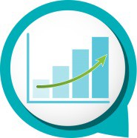 | Unleash potential  - Expect greatness  - Lead and set clear expectations  - Seek, provide and act on feedback

Be courageous
- Own your actions, successes and mistakes
- Take calculated risks
- Act with transparency

Empower people
- Lead, empower and trust
- Play to everyone’s strengths
- Develop yourself and those around you

Our environment
Globalisation, climate adaptation, digital disruption, shifting demographics, cultural diversity and community expectations all form part of the changing landscape within which emergency management operates in Queensland.
The complexity of disasters is increasingly influencing how the Queensland emergency management sector adapts to and plans for events.
Community-centric approaches are emerging that draw on local capability, capacity, leadership and ownership of disaster management in a maturing emergency management system. To mitigate the effects of disasters and build community resilience in Queensland, our current system is directed toward collaboration and cooperation at local, district, state and national levels supported by scalable, agile, interoperable and cost-efficient approaches to emergency management.
Further information about how the Office is responding to these environmental factors can be found in the 2017-18 Highlights (refer pages 14 to 23).

Our strategic challenges
The Office identified the following key strategic challenges for 2017-18 and into the future:
- environmental factors and digital disruption may impact the extent to which barriers to responsive and integrated disaster management are effectively reduced for local governments, state agencies and key partners
- shifting customer expectations may impact the Office’s ability to provide valued and contemporary services to key stakeholders and partners in the emergency management sector, and to ensure state agency participation in arrangements at all levels
- the changing hazard environment and disaster events may limit the opportunity to engage with key stakeholders, and ensure appropriate action is being taken to contribute to resilient communities.

Outlook
In 2018-19, the Office will contribute to Our Future State: Advancing Queensland’s Priorities (launched 11 June 2018) to keep communities safe and be a responsive government through a range of initiatives, including:
- promoting a coordinated strategic direction for emergency management in Queensland
- undertaking targeted reviews that identify risks and prioritise improvements based on community outcomes
- providing system analysis, oversight, monitoring and assurance that builds capability and empowers key stakeholders to effectively deliver their emergency management accountabilities and outcomes
- adopting a collaborative approach to lessons management across the disaster management sector
- designing and embedding contemporary assurance frameworks and tools that are valued by stakeholders and enable improved performance, evaluation and reporting
- seeking and harnessing trusted partnerships that promote collaboration, community-centric engagement, leadership and resilience
- connecting and engaging with key stakeholders through adaptable platforms, systems and process that enable interoperability and good governance
- leveraging current research, analysis and leading practice to inform evidence-based policy and advice.
Key priorities for the Office during 2018-19 include:
- leading the development and implementation of a system-wide lessons management program for Queensland that includes a means of assessing the outcomes of review recommendations
- conducting a Capability Review of the Mount Isa Disaster District, including the district and local disaster management groups
- refreshing the Emergency Management Assurance Framework, including the Standard for Disaster Management in Queensland
- progressing research and collaborative opportunities between local disaster management practitioners and universities
- facilitating knowledge sharing, skills development and collaboration across the sector through a statewide network of disaster management officers.
During 2018-19, key strategic challenges for the Office are:
- balancing competing customer and stakeholder expectations
- actively engaging with emergency management partners in a changing hazard environment
- monitoring advances in emergency management service delivery, systems and platforms.

Our partners
The Office works across the emergency and disaster management sector to improve disaster management outcomes for the community.
It maintains strong relationships with its partners in the community including local governments and non-government organisations.
The Office also works closely with:
- the public safety agencies – Queensland Fire and Emergency Services (QFES), Queensland Police Service (QPS), and the Public Safety Business Agency (PSBA)
- other Queensland Government agencies including Queensland Reconstruction Authority (QRA), Department of the Premier and Cabinet (DPC), Queensland Health (QH), Department of Transport and Main Roads (DTMR), Department of Communities, Disability Services and Seniors (DCDSS), Department of Local Government, Racing and Multicultural Affairs (DLGRMA), Department of Housing and Public Works (DHPW), and Department of Aboriginal and Torres Strait Islander Partnerships (DATSIP)
- the Local Government Association of Queensland (LGAQ) and the Bureau of Meteorology
- the Inspector-General for Emergency Management Victoria.
The PSBA delivers professional information and communication technology, financial, procurement, asset management, human resources, and audit services to the Office. QFES provides the Office with professional legal services.
The Office is committed to maintaining and enhancing these partnerships, and maximising stakeholder liaison and collaboration, by ensuring all communication and engagement activities are based on the four key principles of:
- clear, accurate and timely communication
- accessibility and inclusiveness
- transparency
- measurable outcomes and evaluation.

Structure
As at 30 June 2018, the Office is comprised of:
- Interoperability and Innovation, responsible for the delivery of review and assurance activities and facilitating programs and solutions designed to help the Office and agencies deliver better disaster management outcomes.
- Performance, Reporting and Policy Analysis, responsible for developing and coordinating internal strategy, planning and governance arrangements for the Office.
- Standards, Best Practice and Evaluation, responsible for the delivery of review and assurance activities, management and performance of the Emergency Management Assurance Framework, including the Standard for Disaster Management in Queensland, and the Assurance and Excellence Development Program (AEDP).
- Community and Stakeholder Engagement, responsible for overseeing the active engagement of disaster management stakeholders across all levels of government, tertiary and non-government organisations, and the community.

Financial summary

Summary of financial performance
The following table summarises the operating result and financial position for the Office for 2017-18 and the previous financial year.
Statement of comprehensive income | 2017-18  $’000 | 2016-17  $’000
Total income from continuing operations | 4,925 | 4,591
Total expenses from continuing operations | 4,923 | 4,543
Other comprehensive income | Nil | Nil
Total comprehensive income | 2 | 48
Statement of financial position
Total assets | 1,598 | 1,545
Total liabilities | 436 | 385
Net assets (equity) | 1,162 | 1,160
Income and expenses from continuing operations
The Office is responsible for providing the Minister for Fire and Emergency Services, government and the people of Queensland an assurance of public safety, through the establishment and implementation of an assurance framework to direct, guide and focus work of all agencies, across all tiers of government to the desired outcomes of the disaster and emergency management arrangements for Queensland.
The Office is funded to deliver the above services predominantly through parliamentary appropriations. The Office is supported by the PSBA, which provides corporate support services to the entity. The value of these services received is recognised as income and as an expense in the statement of comprehensive income.
For 2017-18, the Office received income from continuing operations of $4.925 million and incurred total expenditure from continuing operations of $4.923 million. This was comprised predominantly of:
Income
- appropriation revenue $4.22 million
- services received below fair value $0.71 million.
Expenses
- employee expenses $2.90 million
- supplies and services $1.10 million
- grants and subsidies $0.03 million
- other expenses $0.90 million.

Summary of financial position
The Office was in a positive financial position at the end of the financial year. The total equity/net assets of the Office at the end of 2017-18 was $1.16 million. This was comprised of:
Assets
- cash and cash equivalents $1.54 million
- receivables $0.05 million
- plant and equipment $0.007 million.
Liabilities
- payables $0.16 million
- accrued employee benefits $0.12 million
- other current liabilities $0.16 million.
There were no significant events after balance date that could be expected to impact the reported operating result for the Office for the year ended 30 June 2018.

Performance

Key performance measures
The Service Delivery Statement 2017-18 describes the Office’s service area as ‘Independent Assurance and Advice to Improve Emergency Management’.
The Office provides independent assurance and advice about Queensland's emergency management arrangements and authoritative reporting to enhance accountability and improve outcomes for the community.
The Office undertakes a range of assurance activities and system analysis to identify risks to emergency management planning, preparedness, response and recovery arrangements and recommends evidence-based improvements. The most robust assurance activity is a tier three review that has significant depth and rigour and provides a higher level of confidence in the disaster management matter being assessed.
The table below provides an overview of the key performance measures for the Office for 2017-18.
Service Area: Independent Assurance and Advice to Improve Emergency Management
Performance measures | Notes | Strategic  Plan | 2017-18  SDS | 2016-17  Actual | 2017-18 Target/ Estimate | 2017-18  Actual
Customer satisfaction | 1 | - | ✓ | 87% | 80% | 81%
Average cost per tier three review ($'000) | 2 | ✓ | ✓ | - | 200 | 249
Customer satisfaction with Office of the IGEM reviews | 3 | ✓ | - | 78% | - | 75%
Customer perceptions of Office of the IGEM website | 4 | ✓ | - | 86% | - | 88%
Customer satisfaction with Office of the IGEM information and advice | 5 | ✓ | - | 77% | - | 73%
Customer satisfaction with Office of the IGEM staff | 6 | ✓ | - | 90% | - | 91%
Staff perceptions of organisational leadership | 7 | ✓ | - | 59% | - | 76%
Staff perceptions of agency engagement | 7 | ✓ | - | 63% | - | 81%
Staff perceptions of use of flexible work arrangements | 7 | ✓ | - | 67% | - | 73%
Key:
- not available / not applicable
IGEM Inspector-General Emergency Management
SDS Service Delivery Statement
Strategic Plan Office of the IGEM Strategic Plan 2017-21

Notes:
- This service standard assesses overall satisfaction with the Office and is measured as part of an annual customer survey. Customers include the Minister, State and local government stakeholders with a role in disaster and emergency management. It measures the number of respondents who indicated they were either ‘very satisfied’ or ‘satisfied’ (on a 5-point scale ranging from ‘very dissatisfied’ to ‘very satisfied’) with the services and advice provided by the Office represented as a percentage of the total number of responses received.
- This new SDS service standard for 2017-18 measures the average cost to complete a tier three review. Tier three activities aim to assess the effectiveness of a defined aspect of disaster management in Queensland, providing a higher level of confidence in the matter being assessed. The 2017-18 Actual includes the cost of completing The Cyclone Debbie Review. This review was undertaken at the direction of the Minister in response to an emerging event. The scope of the review was broader than the standard planning parameters of a tier three review, attracting additional time and resources and therefore cost. Costs of completing reviews such as contractors, venue and equipment hire, legal advice, staff salaries, travel, accommodation and overheads are included in this measure. Three reviews were completed in 2017-18, as detailed in the Program of reviews (refer pages 14 to 16). The Review of the efficacy of recovery governance, forecast in the Office’s SDS to be completed in 2017-18, is scheduled for completion by September 2018.
- This is a new measure in the strategic plan. It is measured as part of an annual customer survey. It represents the percentage of customers who were ‘very satisfied’ or ‘satisfied’ that advice provided as a result of a review was useful.
- This is a new measure in the strategic plan. It is measured as part of an annual customer survey. It represents the percentage of customers who ‘strongly agree’ or ‘agree’ that the content of the Office’s website is informative.
- This is a new measure in the strategic plan. It is measured as part of an annual customer survey. It represents the percentage of customers who were ‘very satisfied’ or ‘satisfied’ that information or advice given helped improve their business.
- This is a new measure in the strategic plan. It is measured as part of an annual customer survey. It represents the percentage of customers who were ‘very satisfied’ or ‘satisfied’ that the Office’s staff were professional.
- This is a new measure in the strategic plan. It is measured as part of the annual Working for Queensland employee opinion survey which measures workplace climate and use of flexible work options.

2017-18 Highlights
This section reports on the objectives of the Office’s Strategic Plan 2017-2021. This is a sample of performance highlights from 2017-18 and is not representative of all the work undertaken by the Office during the reporting period.

Objective one
Independent assurance and advice to Government, stakeholders and the community enhances strategic direction, accountability and outcomes in Queensland’s emergency management arrangements

Strategies
Promote a coordinated strategic direction for emergency management in Queensland
Undertake targeted reviews and system analysis that identify risks and prioritise improvements on the basis of community outcomes
Design, apply and embed contemporary assurance frameworks, activities and tools that are valued by stakeholders and enable improved performance, evaluation and reporting
Provide system oversight and assurance that enables key stakeholders to deliver their responsibilities and achieve performance outcomes across emergency management

Program of reviews
The Office plans, develops and conducts a range of assurance activities.
Assurance activities undertaken by the Office include a program of strategic reviews. This is one way for the Office to gauge confidence in Queensland’s disaster management arrangements, identify risks and gaps, and prioritise areas for improvement.
Review topics are identified through consultation with disaster management stakeholders and environmental scanning activities conducted by the Office.
Reviews involve a significant depth of enquiry. They produce findings and recommendations for improvements.
In 2017-18, the Office completed three formal reviews:
- Report 1: The Cyclone Debbie Review
In April 2017, in the wake of Severe Tropical Cyclone Debbie and subsequent severe weather events, the Office commenced a review into the effectiveness of Queensland’s disaster management arrangements.
The review looked at three key facets of Cyclone Debbie, namely direct cyclone impact; rapid onset weather conditions after the cyclone’s coastal crossing; and slow onset flooding in the Rockhampton area.
Overall the review found the disaster management system in Queensland performed well in preparing for, responding to, and recovering from Cyclone Debbie.
The review produced 18 recommendations, and identified a significant number of good practice actions taken by state government agencies and local councils.
The review report and the results of a community survey of 1200 residents were released on 18 October 2017.
The review report is available from www.igem.qld.gov.au
- Report 2: Review of capability at a district and local level: Townsville Disaster District
From July 2017 to February 2018, the Office completed a capability review of the Townsville Disaster District.
The Office worked closely with the Burdekin, Charters Towers, Flinders, Hinchinbrook, Palm Island, Richmond and Townsville local disaster management groups, and the Townsville district disaster management group.
The review assessed the individual and collective capacity of these groups against the Standard for Disaster Management in Queensland.
The review produced one recommendation, and found highly effective disaster management capability across the Townsville Disaster District, including many examples of good practice. The achievements of the District reflect the leadership, expertise and commitment of the seven local governments, their local disaster management groups and the district disaster management group.
The review report was released on 4 April 2018.
In May 2018, the Office facilitated a collaborative workshop with the QRA for the local and district disaster management groups. This workshop focused on leveraging the strong leadership demonstrated across the District to develop recovery and resilience capability into the future.
The review report is available from www.igem.qld.gov.au
Report 3: Review of evacuation management arrangements
In 2016, the Office commenced a review of Queensland’s evacuation management arrangements. This review was suspended in April 2017 to conduct The Cyclone Debbie Review. The review re-commenced in October 2017.
The review assessed whether arrangements are scalable and reflect best practice; the extent to which the legislative authority to initiate evacuations is clear; and the capacity for adapting plans to events.
The Office conducted workshops with key stakeholders in Rockhampton, Townsville, Gold Coast and Brisbane as part of the review process. Consultation has been completed and has informed the review report.
The review report was provided to key stakeholders in May 2018 for consideration and response to its recommendations.
In 2017-18, the Office undertook one further review:
- Review of the efficacy of recovery governance
In July 2017, the Office commenced a review of the efficiency and effectiveness of Queensland’s recovery governance arrangements.
The Office engaged 130 stakeholders during the review, including representatives from local councils, state government agencies, non-government organisations, the private sector and community members.
The review uncovered stories that reflect the pride and depth of commitment that people across Queensland have in their efforts to recover from an event, and affirms that for many stakeholders, recovery is deeply personal.
Considerable feedback was provided by stakeholders as part of the review and subsequent consultation. As a result of this interest, the consultation period was extended to beyond 30 June 2018.
The Office is considering the results of consultation, and working toward finalising the review report.

Lessons management
In February 2017, the Office commenced the development of a system-wide lessons management program for Queensland, in response to a recommendation of The Cyclone Debbie Review.
Lessons management is a key way to enable learnings from events, exercises, and good practice to be identified, shared and embedded through action and change.
The Office is working with a broad range of stakeholders from across the sector, including local government, QFES and QPS, who currently play a key role in supporting improvements to Queensland’s disaster management system.
The lessons management program will drive continuous improvement across the sector. Robust monitoring and reporting will further ensure the best possible disaster management system and arrangements are in place in Queensland.

Emergency Management Assurance Framework
The Emergency Management Assurance Framework (the Framework), developed in 2014, underpins the delivery of the Office’s legislated functions and strategic priorities.
The Framework includes the Standard for Disaster Management in Queensland (the Standard), which establishes comprehensive performance outcomes for entities involved in disaster management.
In 2017-18, the Office applied the Framework to key review activities (refer pages 14 to 16).
In April 2018, the Office commenced a refresh of the Framework and the Standard to ensure it remains contemporary and continues to support the disaster management sector into the future.
The refresh involves extensive stakeholder engagement with representatives from local, state and federal governments, not-for-profit organisations and universities. Technical working groups have been established to support stakeholder engagement and provide advice on specific elements of the Framework.
The Office continued to support the practical application of the Framework in the disaster management sector through workshops in 2017-18. Between August and November 2017, eleven regional workshops were conducted with 177 local and district group members.
The Framework and the Standard are available at www.igem.qld.gov.au

Disaster management plans
The Disaster Management Act 2003 requires local government and district disaster management groups to annually review the effectiveness of their disaster management plans, and the Office to regularly review all plans.
The Office provides an online process to enable entities to conduct an annual assessment of their plans against the Standard for Disaster Management in Queensland. This process also enables the Office to carry out its own annual assessment of district and local plans through an analysis of the online results and a sample of plans.
In 2017-18, the annual assessment process was undertaken between July and September 2017. This is the third year that disaster management plans have been assessed against the Standard through an online process.
The most recent assessment showed that overall, plans are ‘well-placed’ across all six areas of Shared Responsibility of the Standard, and that local government and district group confidence has improved since 2016.
An analysis of the assessments and good practice examples were shared with disaster management practitioners to inform future practice.
The Office has recently partnered with DHPW to develop a dashboard where this data can be analysed in different ways, and better presented to the disaster management sector in the future (refer page 19).

Objective two
A culture of excellence and innovation that challenges the emergency management sector to adapt to and explore emerging opportunities

Strategies
Seek and harness trusted partnerships that promote collaboration, community-centric engagement, leadership and resilience
Connect and engage with key stakeholders and partners through flexible and transparent platforms, systems and processes that enable interoperability, open communication and good governance
Leverage contemporary research and analysis to inform evidence-based policy, practice and advice across all phases of emergency management
Provide clear and timely information and advice that builds capability and empowers key stakeholders to effectively meet their emergency management accountabilities

Disaster Management Officers’ Network
Disaster Management Officers (DMOs) are distinct positions within Queensland local governments that have a principal responsibility for disaster and emergency management.
A peer-driven statewide network of DMOs and local disaster coordinators continued to successfully operate in 2017-18. The network was launched in 2015 and provides a way for disaster management practitioners from across Queensland to share knowledge, develop innovative ideas and collaborate.
Facilitated by the Office, the network has grown rapidly to now comprise 91 members from 55 councils across Queensland.
In May 2018, approximately 70 people from local government and Queensland Government agencies attended the 2018 DMO Forum in Townsville. The program included a series of highly-engaging presentations and panel sessions over three days on a vast array of disaster management topics and issues.
Regular teleconferences, and discussion via a secure online collaboration portal, further supported the network to learn from each other, and to identify and implement good practice in 2017-18.
The DMO Network won the Leadership Category at the 2017 Premier’s Awards for Excellence.

Inspector-General Emergency Management Advisory Panel
The Office hosted two Advisory Panel meetings in 2017-18.
The Advisory Panel, established in February 2016, continued to offer practical stakeholder guidance to the Inspector-General Emergency Management.
Panel members include representatives from DPC, QFES, QPS, DCDSS, QH, QRA, LGAQ, Brisbane City Council, Australian Red Cross, Griffith University, and Queensland University of Technology (QUT).
Attendance at Advisory Panel meetings remained strong, ensuring the ongoing contribution of valued expertise to the Office’s activities. Input was provided into a range of critical emergency management issues including recovery governance, evacuation management arrangements, lessons management, and the Office’s strategic direction.

Innovative platforms and systems
The Office applied innovative platforms, systems and processes to support the delivery of quality services to key stakeholders during 2017-18.
The Office recently partnered with the DHPW to share insights about the annual assessment of disaster management plans across the State through an interactive dashboard. The dashboard leverages leading-edge software to enable local governments to examine their assessment data in new ways (refer pages 16 to 17). It combines three years of self-reported emergency management planning data with population, revenue and disaster activation data to provide a rich picture of a region’s confidence in disaster management.
The Collaboration Zone, a secure online platform released in 2016 to support information sharing within key stakeholder groups, continued to grow in usage. Individual zones were developed to:
- connect academics with disaster management practitioners for research purposes
- support inter-jurisdictional sharing of emergency management assurance policy and practice
- enable experts in Queensland’s emergency management sector to contribute to the development of a lessons management program.
In support of the system-wide lessons management program (refer page 16), the Office has participated in the Advance Queensland Testing Within Government (TWiG) Program, and is exploring the opportunity to work with a small to medium sized enterprise to develop an innovative solution that will enable the sector to better understand data and information about dealing with disasters across Queensland.
A secure online platform, Basecamp, continued to underpin the award-winning DMO Network. The platform enabled those in local government to connect with their peers in the sector around a range of key issues.
In 2017-18, the Office started to progressively implement Nexus, a Human Capital Management product. This activity was supported by QFES and DHPW. Nexus went live in December 2017, enabling Office staff to access a home page, profile and learning module. Implementation of Nexus will continue into 2018-19, and once fully rolled out will become a ‘one-stop-shop’ for recruitment, onboarding, learning, workplace health and safety, workforce reporting, case management, performance and goals, succession and development.
Work also commenced in 2017-18 to:
- scope a refresh of the Office’s website to ensure the Office’s online presence remains contemporary
- procure and introduce software to support better resource management, tracking and reporting against the Office’s key projects, review and assurance activities
- scope and develop a tailor-made repository on the Basecamp platform to better facilitate the sharing and access of documents, materials and examples of good practice within the Disaster Management Officers’ Network.

Research framework and engagement with universities
The Office continued to collaboratively develop and promote disaster management research for the Queensland context during 2017-18.
A peer-driven research framework, initiated by the Office in 2016-17, nurtured partnerships, cooperation and understanding between institutions, government agencies and disaster management practitioners. A network of champions from the tertiary and disaster management sectors continued to oversee the framework, and a dedicated advisory group was established to drive collaborative initiatives.
Development and implementation of the framework was supported by an online platform in 2017-18, enabling effective discussions between disaster management practitioners and researchers.
A Research Community of Practice hosted by the Office continued to grow. A database of more than 130 university researchers specialising in disaster and emergency management from a broad range of disciplines has been developed.
Current research projects involving the Office include:
- a practical proof of concept investigation and exercise looking at the use of augmented and virtual reality in a disaster scenario, using QUT’s Gardens Point campus
- an audit, benchmark, literature review and needs analysis of practitioners across Queensland in relation to the data and information they need to make evidence-based decisions at the local level, in partnership with Griffith University
- scoping of the potential use of augmented and virtual reality in the context of evacuation from aged care facilities across Queensland
- a study and literature review to identify good practice in community engagement in a disaster management context, creation of a community preparedness competency index, and development of a framework and toolkit for use by practitioners at the local level, in partnership with QUT and University of Southern Queensland.
During 2017-18, the Office continued to support undergraduate studies in disaster management through a Memorandum of Understanding (MOU) with QUT. This MOU includes a 10-week internship with the Office. During this year’s internship, a scoping paper was prepared, and a seminar delivered to key stakeholders on environmental challenges and opportunities associated with the application of the National Principles for Disaster Recovery within Queensland.
The Office also assisted local disaster management officers to scope postgraduate study options, provided research guidance to local and state agencies, and maintained a register of research issues and questions.

Stakeholder engagement
Significant engagement was undertaken with key stakeholders in 2017-18.
The Inspector-General Emergency Management (IGEM) and the Office continued to provide strategic input into State arrangements through the Queensland Disaster Management Committee (QDMC), State Disaster Coordination Group (SDCG), and Disaster Management Interdepartmental Committee.
Consultation was undertaken with Chief Executive Officers to seek their input into key assurance activities such as reviews conducted during the 2017-18 financial year, and to inform the Office’s forward program of work in 2018-19.
Regular engagement occurred over the course of the year with key executives and stakeholders in the emergency management sector including QFES, QPS, QRA, DPC, DHPW, DTMR, QH, DCDSS, DATSIP, and PSBA.
The Office attended a number of exercises, in Noosa, Gympie, Richmond, Hughenden, Redlands and Palm Island.
Thought leadership and information sharing was delivered through:
- presentations and attendance at key Queensland conferences, symposiums and workshops including Australasian Fire and Emergency Services Authorities Council (AFAC) Conference; Bushfire and Natural Hazards Cooperative Research Centre (BNHCRC) Research Forum; Australian Strategic Policy Institute; Council on the Ageing (COTA) State Disaster Preparedness for Older People; and Volunteering Queensland workshops with local government to engage aged care providers
- active participation in committees and working groups such as the Brisbane River Strategic Floodplain Management Plan Working Group; Flood Warning Consultative Committee; Ready and Resilient Working Group; Queensland Tropical Cyclone Consultative Committee; Queensland Heatwave Risk Assessment Interdepartmental Project; Disaster Management Sector Adaptation Plan Advisory Group; Open Data Senior Officers Working Group; and Innovation Champions Network.
Contributions were made to the national agenda through:
- co-hosting a two-day Australia/New Zealand Inspector-General Emergency Management Collaborative with Victoria IGEM in March 2018
- contribution to the Australian Vulnerability Project and National Warnings Framework Working Group
- journal publications on issues such as best practice emergency supply (Journal of Humanitarian Logistics and Supply Chain Management, March 2018) and lessons management (Australian Journal of Emergency Management, April 2018) and presentations at interstate conferences
- steering and working group involvement with the Australian Institute of Disaster Resilience regarding the review of the Emergency Management Australia Glossary
- AFAC sponsored Lessons Management forum in October 2017.
Key information and outcomes of assurance activities were communicated to the emergency management sector and the community through tabling of review reports in Parliament (refer pages 14 to 16); issuing four editions of the Office’s online newsletter IGEM Connect (available at www.igem.qld.gov.au); and providing updates on the Office’s website and social media.

Objective three
Our workforce is diverse, forward-looking, agile and engaged

Strategies
Actively champion inclusion and diversity
Foster a culture of service excellence and high-performance that models our values
Strengthen our workforce capability, knowledge management, information sharing and use of common language
Leverage opportunities to create and apply leading practice, collaborative and mutually supportive service delivery models

Inclusion and diversity
The Office continued to champion inclusion and diversity in 2017-18:
- in support of the release of the Office’s Inclusion and Diversity Plan 2017-19 in October 2017, key activities included promoting Diversity Council Australia membership and events that celebrate cultural diversity, people with disability and LGBTIQ+ persons; collaborating with public safety agencies to deliver an International Women’s Day event for over 700 people; hosting the IGEM Champion of Change award; and attending the national Diversity in Disaster Conference in April 2018.
- delivering key actions in the Office’s Aboriginal and Torres Strait Islander Cultural Capability Plan 2017-18 focused on valuing culture (recognising and commemorating significant events); building cultural capability (through corporate induction); and engagement (consulting Aboriginal and Torres Strait Islander stakeholders as part of review activities).
- actively participating in activities to support White Ribbon Australia Workplace Accreditation, achieved in November 2017. Activities included participating in the Candlelighting Vigil and Darkness to Daylight events; promoting Queensland Women’s Week; and participating in domestic and family violence prevention training (refer page 33).
- promoting activities that support the safety, health and wellbeing of Office staff such as influenza vaccinations; mental health; Safe Work Month; stroke assessments; promoting the employee assistance program; and supporting flexible work practices including telecommuting and part-time work (refer pages 33 to 34).

Service excellence
The Office continued to build a high-performing workforce with a customer-centric focus in 2017-18 through key activities:
- all employees were provided with the opportunity to engage in regular performance conversations as part of the Office’s performance and development planning (PDP) process, and to contribute to a constructive workplace culture through one-on-one discussions with the IGEM, regular team and Office-wide meetings. A more contemporary approach to PDP is likely to be realised through Nexus as it continues to be implemented in 2018-19 (refer page 19).
- the IGEM fostered a culture of service excellence as an observer of the PSBA Board of Management; as a member of PSBA Committees for audit, workforce, business, information and communication technology services; and as a contributor to the review of service agreements with PSBA and QFES.
- the Office’s values continued to be embedded through the application of the AEDP. This is the tool used by all staff to guide the process for conducting assurance activities.
- the Office sought input from the IGEM Advisory Panel (refer pages 18 to 19) and all staff during March to April 2018 to develop a refreshed Strategic Plan 2018-22. The Office’s Strategic Plan and program of work for the 2018-19 financial year informed the development of the Office’s Operational Plan for 2018-19.
Satisfaction with the services delivered by the Office continued to be extremely high. In February to March 2018, the Office conducted its annual customer satisfaction survey of key stakeholders. Overall, 81% of stakeholders were ‘very satisfied’ or ‘satisfied’ with the services provided by the Office, exceeding the target of 80% satisfaction. No respondents were ‘very dissatisfied’ with services overall. These survey results were shared with staff and opportunities to improve service delivery identified. Refer pages 12 to 13 for further information on customer satisfaction with the Office’s service delivery.

Workforce capability
The Office’s Workforce Strategy 2017-21 was realigned to better reflect sectorwide workforce issues, and promoted to all staff. The Office’s Workforce Strategy Sub-Committee met on four occasions.
Workforce capability continued to be strengthened through:
- contemporary recruitment and selection practices
- staff participation in a range of targeted leadership and development activities including the Executive Challenge Academy leadership course; People Matters Program; and a five-day in-house leadership development program
- supporting mobility of staff from other public safety agencies and local government to work in the Office.
The Office continued to promote the use of common language through the lexicon project. The draft of the inaugural Queensland Disaster Management Lexicon was endorsed by the IGEM Advisory Panel (refer pages 18 to 19) in November 2017. The lexicon contains more than 100 terms sourced from Queensland legislation and guidelines, and includes reference to relevant national and international terms. Engagement with the Lexicon Working Group was undertaken on an as needs basis throughout 2017-18. The Office also played a key role with the Australian Institute for Disaster Resilience Glossary Steering Committee and Working Group. The lexicon will complement the Office’s existing publications and support the refresh of the Emergency Management Assurance Framework (refer page 16).
Working for Queensland employee opinion survey
The Office participated in the sectorwide Working for Queensland employee opinion survey in July to August 2017. The survey measures workplace climate and gives employees the opportunity to provide their views and opinions about a wide range of workplace factors. The Office achieved a response rate of 100% in 2017.
Results were positive for agency engagement (81%), organisational leadership (76%), innovation (89%), and use of flexible work practices (73%) (refer pages 18 to 19). These results were explored in staff workshops. A number of activities have been progressively implemented to facilitate workplace improvements across the Office. These include flexible work practices; information sharing; and staff participation in planning, leadership and management development programs. These ensure that the Office continues to be a great place to work.

Governance

Executive management
Iain MacKenzie AFSM. MLshipMgt (Policing)AFSM. Policing)
Inspector-General of Emergency Management
The Inspector-General of Emergency Management is responsible for leading and managing the Office to provide assurance and advice to enable confidence in Queensland’s disaster and emergency management arrangements.
The Office regularly reviews and assesses the effectiveness of disaster management by local, district and state disaster management groups, including reviewing disaster management plans, regularly reviewing and assessing entities against the Standard, working with agencies to improve Queensland’s disaster management arrangements, and identifying opportunities for cooperative partnerships to improve disaster management outcomes.
Prior to Iain’s appointment as Inspector-General of Emergency Management, he was the Deputy Commissioner of the former Queensland Fire and Rescue Service and served in the fire service for over 32 years. Iain holds a Masters Degree in Leadership and Management, is a graduate of the Institute of Fire Engineers and has attended the United States National Fire Academy Executive Fire Officer Program. Iain was awarded the Australian Fire Service Medal in 2006.

Mike Shapland MBE
Director, Interoperability and Innovation
The Director, Interoperability and Innovation leads review and assurance activities, and facilitates programs and solutions designed to help the Office and agencies deliver better disaster management outcomes. The role represents the Office at innovation forums and promotes interoperability across the sector.
Mike is a graduate from the Royal Military Academy, Sandhurst, the British Army’s Technical and General Staff courses and Griffith University’s Master of Business Administration program. Mike was awarded Member of the Order of the British Empire in the United Kingdom’s 1997 New Year’s Honours list.

Sarah March
Director, Performance, Reporting and Policy Analysis
The Director, Performance, Reporting and Policy Analysis is responsible for developing and coordinating internal strategy, planning and governance arrangements for the Office. The role also acts as a liaison point with PSBA and other agencies in relation to external policy and governance, and provides policy advice to the Inspector-General of Emergency Management and the Office’s Executive Management Committee (EMC).
Sarah holds a Bachelor of Arts (Psychology) and Post Graduate qualifications in Psychology.

Rowena Richardson
Director, Standards, Best Practice and Evaluation
The Director, Standards, Best Practice and Evaluation leads review and assurance activities, and is responsible for the management and performance of the Emergency Management and Assurance Framework, including the Standard, and the AEDP. This role also has oversight of the Lessons Management Program.
Rowena has specific expertise in systems analysis and improvement, holds a Master of Health Administration, a Bachelor of Health Science and Post Graduate Certificates in Critical Care Nursing, Health Management and Business.

Phil Nickerson
Director, Community and Stakeholder Engagement
The Director, Community and Stakeholder Engagement oversees the active engagement of disaster management stakeholders across all levels of government, tertiary and non-government organisations, and the community. The role also provides strategic advice to the Inspector-General of Emergency Management and the Office’s EMC regarding corporate communications, media relations and issues management.
Phil holds a Bachelor of Business (Communications) and a Bachelor of Business (Accountancy).

Committees
The Office governance structure comprises the Executive Management Committee and the Public Safety Portfolio Audit and Risk Committee.

Executive Management Committee
The EMC is the key leadership group for the Office. The committee provides leadership and direction on strategic and operational issues and supports the Inspector-General Emergency Management as the accountable officer under section 61 of the Financial Accountability Act 2009, to achieve efficient, effective and financially responsible management for the Office.
The committee meets monthly unless otherwise determined by committee members. Extraordinary meetings may be called at the discretion of the Chair.
During 2017-18, the committee met on 11 occasions.
Committee members
- Iain MacKenzie AFSM, Inspector-General Emergency Management (Chair)
- Mike Shapland MBE, Director, Interoperability and Innovation
- Sarah March, Director, Performance, Reporting and Policy Analysis
- Rowena Richardson, Director, Standards, Best Practice and Evaluation
- Phil Nickerson, Director, Community and Stakeholder Engagement
In 2017-18, the EMC:
- provided strategic oversight for all Office reviews, assurance activities and major projects
- endorsed the Office of the IGEM Strategic Plan 2018-2022
- endorsed the Office of the IGEM Operational Plan 2018-2019.

Public Safety Portfolio Audit and Risk Committee
The Public Safety Portfolio Audit and Risk Committee (ARC) is established under, and operates in accordance with, the terms of its charter, which were developed in line with Queensland Treasury’s Audit Committee Guidelines: Improving Accountability and Performance, the Financial Accountability Act 2009, and the Financial and Performance Management Standard 2009. The charter is reviewed annually by the committee to ensure it remains consistent with the committee’s authority, objectives and responsibilities.
The committee has primary responsibility for audit and risk matters as they relate to the Office and PSBA. It provides relevant information to the standalone Audit and Risk Committees established by QFES and QPS when required. It provides independent assurance and assistance through prompt and constructive reports directly to the accountable officers from the public safety agencies, particularly when issues identified present material risk or threat to those agencies.
The committee is chaired by an independent external expert appointed to the role. Each public safety agency is represented by one member. A second external member also forms part of the committee. The Chair may invite or give approval for other persons to attend a committee meeting.
The committee meets quarterly and met on five occasions during 2017-18.
The independent external Chair received $9,622.75 (including GST) in remuneration for services provided in 2017-18. The second external member received $4,812.50 (including GST). There were no other on-costs.
Committee members
- Graham Carpenter, Chair (external member)
- Ian Stewart APM, Commissioner, QPS represented by Tracy Linford APM, Deputy Commissioner, Strategy, Policy and Performance, QPS
- Katarina Carroll APM, Commissioner, QFES represented by Doug Smith APM, Deputy Commissioner, Chief Strategy Officer, Strategy and Corporate Services, QFES
- Iain MacKenzie AFSM, Inspector-General Emergency Management
- Peter Griffin, Chief Operating Officer, PSBA
- Marita Corbett (external member)
During 2017-18, the committee’s achievements include:
- overseeing progress on Queensland Audit Office (QAO) issues and the status of the QAO Audit Program
- considering all audit reports and providing direction regarding implementation of report recommendations and actions
- monitoring compliance with the Annual Internal Audit Plan 2017-18 and Strategic Internal Audit Plan 2018-2021 and overseeing the status of open recommendations
- contributing to the development of the PSBA Enterprise Risk Management Policy
- endorsing the:
  - PSBA Financial Statements 2017-18
  - Office of the IGEM Financial Statements 2017-18
  - PSBA Annual Internal Audit Plan 2018-19 and Strategic Internal Audit Plan 2019-22
  - Office of the IGEM Risk Management Framework and Guide
  - PSBA and Office of the IGEM Fraud and Corruption Prevention and Control Policy and Plan.

Ethics and Code of Conduct

Ethical standards
Human Resources Division’s Employee Relations Unit in PSBA assesses complaints regarding the conduct of staff and contractors in the Office. The unit assesses complaints in accordance with the Management of Complaints about Employees, Volunteers and Contractors Policy and Procedure. As outlined in the procedure, certain categories of complaints will be formally investigated by the Employee Relations unit, while others may be referred back to management to address.
The unit also has the following key roles and responsibilities:
- recording all complaints in the complaints management system except for Conduct and Performance Excellence (CaPE) Category 1 matters (Category 1 matters involve inappropriate interpersonal conduct with colleagues, clients or other stakeholders, inappropriate behaviour relating to minor management matters, and performance requiring improvement)
- acting as the central liaison point for the Crime and Corruption Commission (CCC) and the Queensland Ombudsman, and discharging the agency’s statutory obligations under the Crime and Corruption Act 2001
- overseeing the Public Interest Disclosure framework and assisting the agency in fulfilling its statutory obligations under the Public Interest Disclosure Act 2010
- coordinating requests for Internal Review lodged by persons who are dissatisfied with the way their complaints have been handled by the agency.

Code of Conduct
The Office partnered with the PSBA to deliver corporate induction sessions for new employees in 2017-18. These training sessions included information about workplace behaviours as well as an overview of the Code of Conduct for the Queensland Public Service.
In addition, Office employees were provided with the opportunity to attend a negative workplace behaviours information session conducted by the PSBA Conflict Management Services unit.

Risk management and accountability

External scrutiny
A number of state bodies have been established by legislation to provide independent views and/or assurance of government performance. During 2017-18, the following state bodies examined the operations of the Office or other agencies with findings and issues requiring consideration by, or impacting on, the Office.
- Crime and Corruption Commission
The CCC is a statutory body set up to combat and reduce the incidence of major crime and corruption in the public sector in Queensland. Its functions and powers are set out in the Crime and Corruption Act 2001. The CCC investigates crime and corruption, has oversight of both the police and the public sector, and protects witnesses.
The Office refers to the Commission’s Corruption Prevention Advisory resources, which assist public sector agencies to identify major corruption risks and develop prevention strategies, as required.
- Queensland Audit Office
The QAO supports the role of the Auditor-General of Queensland in providing Parliament with an independent assessment of the financial management and performance activities of public sector entities. The QAO provides an independent audit service and reports to Parliament to enhance public sector accountability. QAO reports are available online at www.qao.qld.gov.au.
- Report to Parliament No. 6: Fraud risk management
The QAO assessed if agencies appropriately identify and assess fraud risks, and apply appropriate risk treatments and control activities to adequately manage their exposure to fraud risk; and if agencies’ risk management plans effectively target and address fraud risks and if there were any obvious omissions from risk registers.
The audit included QFES, PSBA and QPS.
The Office was not an audited entity, however the audit directed three recommendations at all government agencies.
During 2017-18, in partnership with PSBA, the Office developed and implemented a Fraud and Corruption Prevention and Control Policy and Plan. The Office intends to conduct a fraud risk assessment in 2018-19.
- Report to Parliament No. 8: Confidentiality and disclosure of government contracts
This audit examined the use of confidentiality provisions in Queensland Government contracts. It assessed whether selected departments met contract disclosure requirements and included the:
- adequacy of current guidance available to aid staff in these activities
- impact of these activities on accountability and transparency.
The Office was not an audited entity, however recommendations three and four of the report were directed at all government agencies.
In relation to recommendation three (agencies to meet the mandatory requirements set out in Procurement Guidelines – Contract Disclosure), the Office utilises the services of the PSBA’s central procurement function to report contract disclosures. In accordance with the Guidelines, processes are in place to ensure that the Office has reporting capability to disclose contract payments over $10,000 in value.
In relation to recommendation four (agencies to improve their contract registers or contract management systems to ensure a complete record of all awarded contracts), the Office utilises both the whole-of-government finance system (i.e. SAP) and contract management system (i.e. Q-Contracts) to provide a complete record of contract information as required. Through the central procurement function of the PSBA, the Office will look to implement any system improvements introduced at the whole-of-government level.
- Report to Parliament No. 11: Queensland state government: 2016-17 results of financial audits
Most public sector entities prepare annual financial statements. The Auditor-General of Queensland is responsible for providing Parliament with independent assurance of the financial management of public sector entities by auditing these financial statements. The report summaries QAO’s analysis of the financial position, performance and sustainability of the Queensland state government, and the timeliness and quality of financial reporting by public sector entities controlled by the state government.
No significant findings or issues were identified for the Office in this report.

Internal audit
The PSBA Internal Audit Unit is an independent unit that provides advice across a wide range of disciplines including risk, assurance, information technology, finance, compliance and general consulting activities for the public safety agencies including the Office.
The Head of Internal Audit, PSBA is also the nominated Head of Internal Audit for the Office in accordance with the Financial Accountability Act 2009.
The work of the Internal Audit Unit is undertaken in accordance with the Institute of Internal Auditors’ standards and under an approved charter which is consistent with relevant audit and ethical standards.
In accordance with the Financial and Performance Management Standard 2009, an annual internal audit plan and three year strategic audit plan sets the direction of the unit. The PSBA Annual Internal Audit Plan 2017–2018 and Strategic Internal Audit Plan 2018-2021 was endorsed by the Agency Audit and Risk Committees and approved by the Chair of the PSBA Board of Management on 25 September 2017.
The Internal Audit Unit ensures all relevant guidelines, particularly Queensland Treasury’s Audit Committee Guidelines: Improving Accountability and Performance, are adhered to, and the functioning of the unit complies with these guidleines in all material respects.
The unit assists management to achieve its objectives by using a systematic, disciplined approach to review and improve the effectiveness of risk management and internal control and governance processes, improving the overall level of compliance and accountability. Under its approved charter, the unit can undertake a series of review types including compliance (effectiveness), performance (efficiency), financial management and information technology, to identify areas of risk and to improve outcomes. Systems are in place to ensure the effective, efficient and economic operation of the audit function.
Achievements for 2017-18 include:
- progressed delivery of the approved Annual Internal Audit Plan 2017-18 through a combination of in-house and co-sourced delivery. At 30 June 2018, all fieldwork was completed and all audit reports are expected to be finalised by the end of September 2018.
- conducting reviews of the public safety agencies, including those relevant to the Office (cyber-crime prevention; open source intelligence; and social engineering)
- completing ad-hoc or unplanned reviews covering emerging risk areas including delegations and fraud risk assessment
- implementing best practice internal audit processes including:
  - undertaking an internal audit maturity assessment
  - developing an industry-leading internal audit strategy and internal audit lifecycle
  - formalising an internal audit quality assurance and improvement program.

Risk management
Effective management of risks and opportunities is considered by the Office as critical to maximising organisational performance in the achievement of strategic objectives. The Office is continuing to build strong, proactive and effective risk management processes that support quality and responsive service delivery and optimal resource management.
The Office’s risk management approach is governed by the Risk Management Framework and Guide to Strategic and Operational Risk Management. The framework and guide provide a consistent approach to identifying, mitigating and monitoring organisational risk, and ensure the Office complies with the risk management requirements in the Financial Accountability Act 2009.
During 2017-18, in partnership with PSBA, the Office developed and implemented a Fraud and Corruption Prevention and Control Policy and Plan.
Strategic and operational risks are monitored and reviewed by the Office’s Executive Management Committee on a regular basis to ensure the Office is well placed to deliver its strategic objectives and operational activities.
The Office sought support and advice from PSBA in relation to risk management matters where necessary, and attended relevant training and briefing activities.

Information systems and recordkeeping
PSBA, as the provider of corporate support services to the Office, is responsible for recordkeeping and information systems. The Office receives advice and assistance from PSBA through a dedicated records management team, known as the Information Management Unit.
In 2017-18, the Office continued to use Mincor for ministerial correspondence, network drives to manage electronic documentation and RecFind to manage hard copy records.
Information on recordkeeping responsibilities is communicated to all staff through the Office’s AEDP and other internal processes.
No Office records were transferred to Queensland State Archives during 2017-18.

Human resources
Strategic workforce planning and performance

The PSBA delivers quality human resource (HR) services to the Office. These services are delivered under a Service Agreement and Catalogue, which clearly outlines the responsibilities of both agencies in relation to HR services to support the achievement of the Office’s strategic workforce priorities.

Workforce profile
The total number of Full Time Equivalent (FTE) staff for the Office was 21.06 as at 30 June 2018.
Between 1 July 2017 and 30 June 2018, the Office’s permanent separation rate was 14%. The separation rate is for permanent staff only and excludes contract staff.
Corporate induction
The Office recognises the importance of onboarding and inducting new employees. It provides an introduction to the working environment and facilitates orientation of employees to the organisation.
New employees who commenced with the Office in 2017-18 attended a comprehensive corporate induction program.
The Office partnered with the PSBA to deliver this program on a quarterly basis.
The program was recently realigned to enhance interaction and engagement with attendees. It provides participants with the opportunity to interact with senior management, hear from divisional and portfolio representatives and network with colleagues. The program covers a broad range of topics including: corporate vision and strategic objectives, conditions of employment, employee entitlements, workplace conduct and performance, safety and wellbeing and diversity and inclusion.
Feedback from attendees continues to be positive with attendees valuing the opportunity to personally meet and hear from senior leaders from across the public safety agencies.
Performance management
Central to the Office’s success is the commitment to develop and support a diverse, forward-looking, agile and engaged workforce.
All employees were provided with the opportunity to engage in regular performance conversations as part of the Office’s PDP process; supporting the achievement of performance outcomes and delivery of the Office’s strategic objectives. PDP discussions are also a catalyst for progressing professional development and capability building across the Office.
International Women’s Day
International Women’s Day (IWD) is a global day to celebrate and reflect upon the economic, political and social achievements of women across the globe.
The Office celebrated IWD on 8 March 2018 by jointly organising a public safety agencies luncheon event. The theme of the event was ‘Connecting and empowering through partnerships‘. The keynote speakers for the event were Kay McGrath, journalist, presenter and child safety campaigner and Cynthia Morton, Author, Emotional Fitness Specialist/Hope Masseuse. The keynote speakers were also joined by Queensland Police Inspector, Corey Allen and Madeline Price who engaged in a panel discussion on the theme of the event. Over 720 people attended.
The event also included a public safety agencies awards ceremony, which recognised and acknowledged the achievement of staff across a number of award categories.
Domestic and family violence support package
The Office achieved accreditation in November 2017 as a White Ribbon Australia Workplace in recognition of the active steps taken to prevent and respond to violence against women.
The Office was recognised for effective leadership and visible commitment to domestic and family violence (DFV) prevention; allocation of resources to prevent and respond to DFV; development of policies, procedures and resources; delivery of training programs for managers and employees to build confidence and capabilities in addressing DFV; and participation in events and initiatives to raise awareness of DFV in the workplace and across the broader community. Management and staff in the Office have been equipped with the knowledge and skills to address the issue of DFV. The Office will continue to foster a workplace culture where employees affected by DFV are supported by providing appropriate safety and support measures. This will contribute to a healthy and safe working environment for all.
The Employee Assistance Program (EAP) offers professional support to employees experiencing DFV. Employees can contact a direct line which will provide access to professionals who specialise in DFV. The service offers confidential professional support, counselling and referrals to community support services, information and a range of resources.
The Office participated in several events and initiatives to promote gender equity and the prevention of violence against women. These included events held during Queensland Women’s Week and Queensland’s Domestic and Family Violence Prevention Month. The Office also partnered with PSBA and QPS to host a Trivia Night in July 2017 to celebrate White Ribbon night.
In 2017-18, the Office again participated in the Darkness to Daylight Challenge, an annual overnight 110km run that raises community awareness and support for those affected by DFV. A team of staff competed in the event by running and walking to show support for those affected by DFV. Staff also attended a Candlelight Vigil on 2 May 2018 to remember those lost to DFV in the past year.
Employee assistance
In 2017-18, an EAP continued to be available to Office employees. Through the EAP, all Office employees and their immediate family members have access to a professional, independent and confidential counselling and coaching service. The EAP promoted employee wellbeing through information and services designed to support them to effectively manage their professional and personal wellbeing.
Health and wellbeing
The Office is committed to fostering a supportive working environment which assists employees in maintaining health and wellbeing.
A number of initiatives, articles and information were promoted and featured during Safe Work Month in October 2017 to raise awareness of health and safety in the workplace and support employee wellbeing. This included an information session on supporting employee health and wellbeing, delivered by the Office’s EAP service provider.
In September 2017, the Office participated in a program that offered employees the opportunity to attend complimentary checks to assess the risk of stroke. This was undertaken through a professional not-for profit organisation. Coinciding with National Stroke Week, it provided the opportunity to raise awareness of the risk factors and signs of stroke.
In June 2018, the Office participated in the Wellness @ Work Month initiative. During this month employees were invited to attend various events and activities to promote health and wellbeing, including a Health and Wellbeing Expo which featured stalls and information from a range of exhibitors to support a healthy lifestyle; wellbeing workshops focused on building resilience, balancing your life and managing work pressures; financial wellbeing seminars; yoga classes; and nutrition seminars.
Workplace health and safety
The Office is committed to meeting its workplace health and safety obligations. In 2017-18, the Office promoted EAP support services, DFV awareness programs and the management of injury and illness in the workplace to employees.
The Office continued to supported injured or ill employees through proactive case management and the development of rehabilitation and return to work plans on a case-by-case basis.
The Office is working with the PSBA to review and develop relevant policies, templates and guidelines to ensure obligations under workplace health and safety legislation continue to be met. In collaboration with the PSBA, a pandemic plan has been developed. The Plan provides direction on minimising the health consequences of an influenza pandemic on employees and disruption to business operations.
In April and May 2018, the annual influenza vaccination program was offered to Office employees. A large proportion of employees registered to receive a vaccination.

Early retirement, redundancy and retrenchment
No early retirement, redundancy or retrenchment packages were paid to Office employees during the period 1 July 2017 to 30 June 2018.

Financial statements – Table of Contents
Statement of comprehensive income 36
Statement of financial position 37
Statement of changes in equity 38
Statement of cash flows 39
Notes to and forming part of the financial statements 2017-18 40
Management certificate 51
Independent Auditor’s report 52

Statement of comprehensive income

Statement of financial position
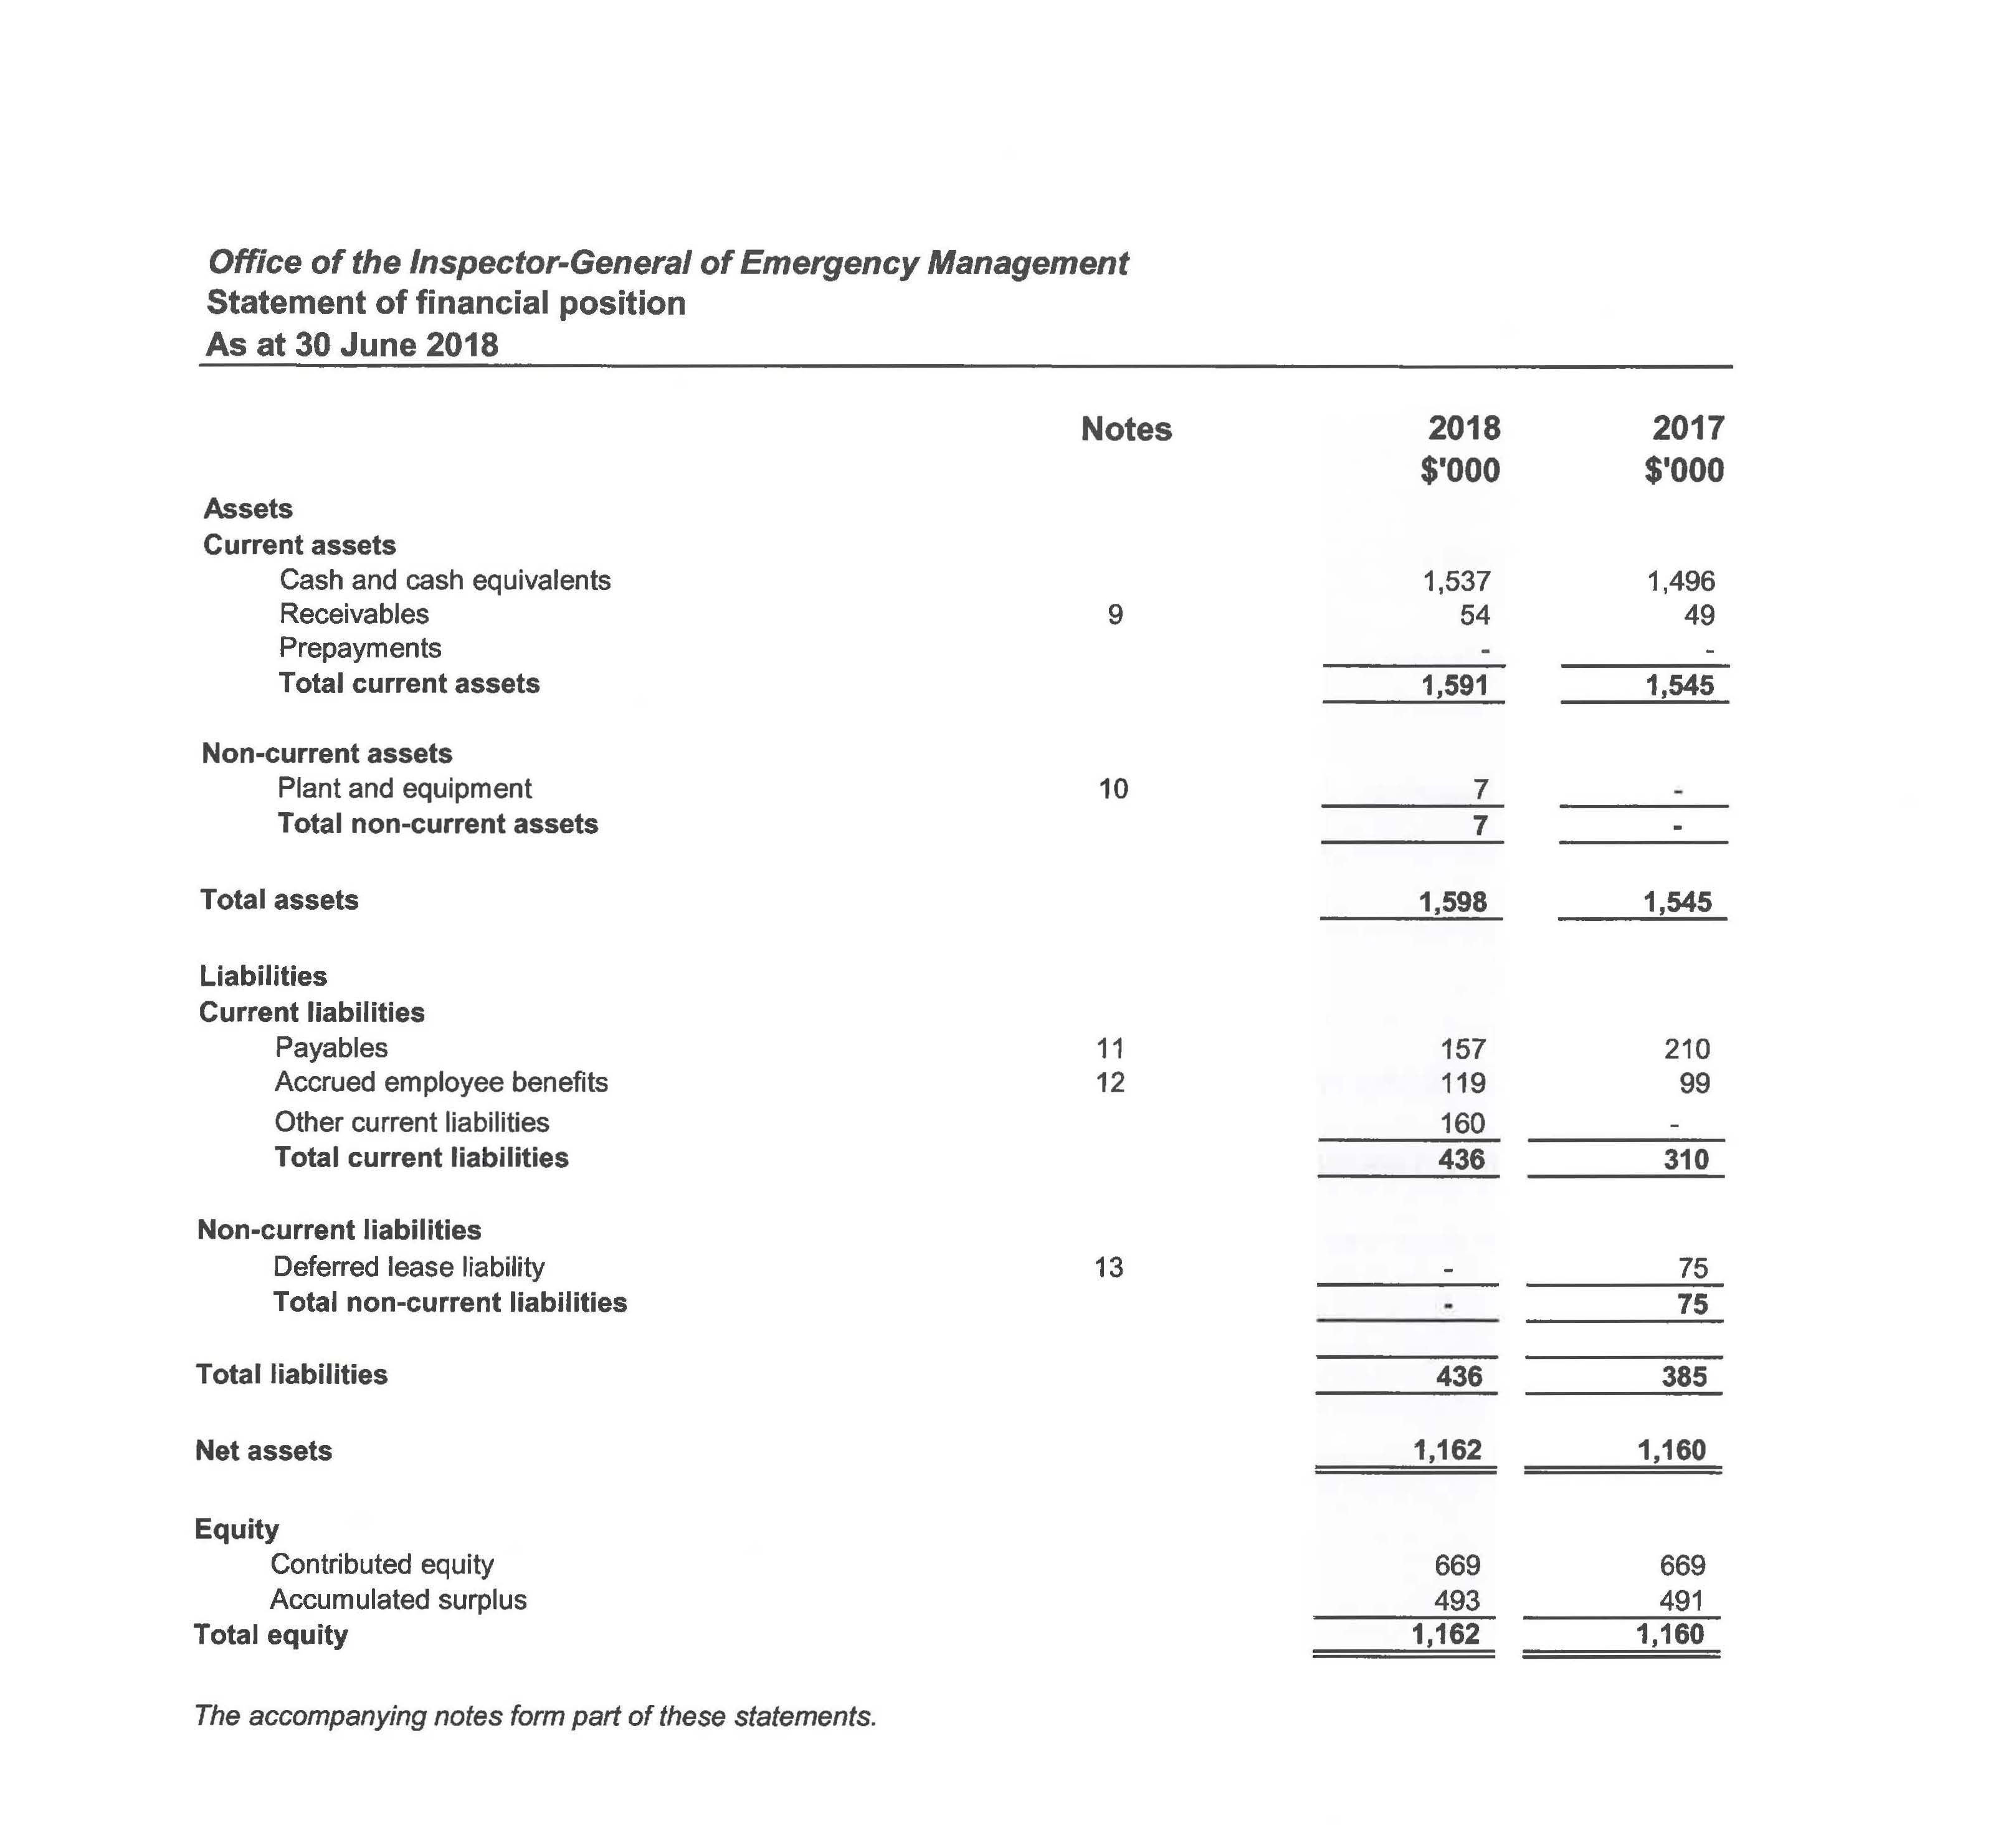

Statement of changes in equity

Statement of cash flows
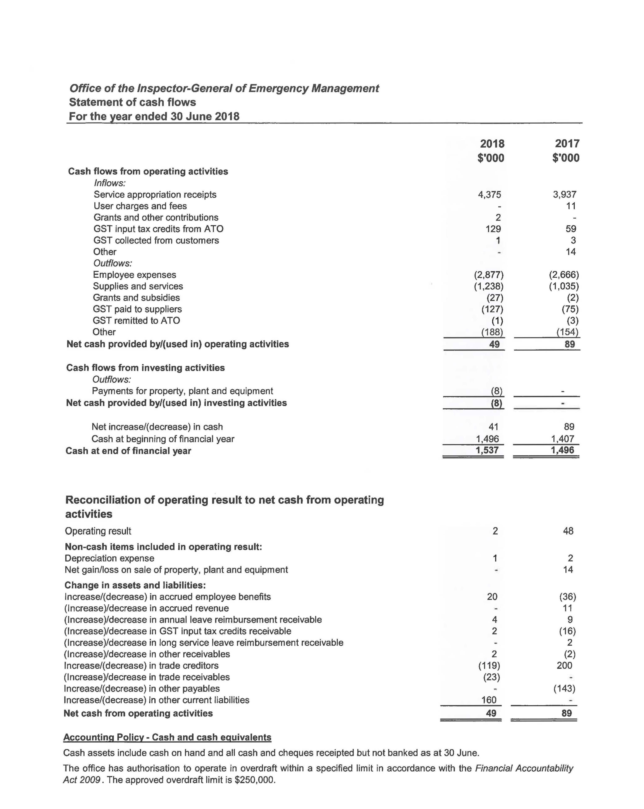

Notes to and forming part of the financial statements 2017-18

Notes to and forming part of the financial statements
2017-18 (cont’d)
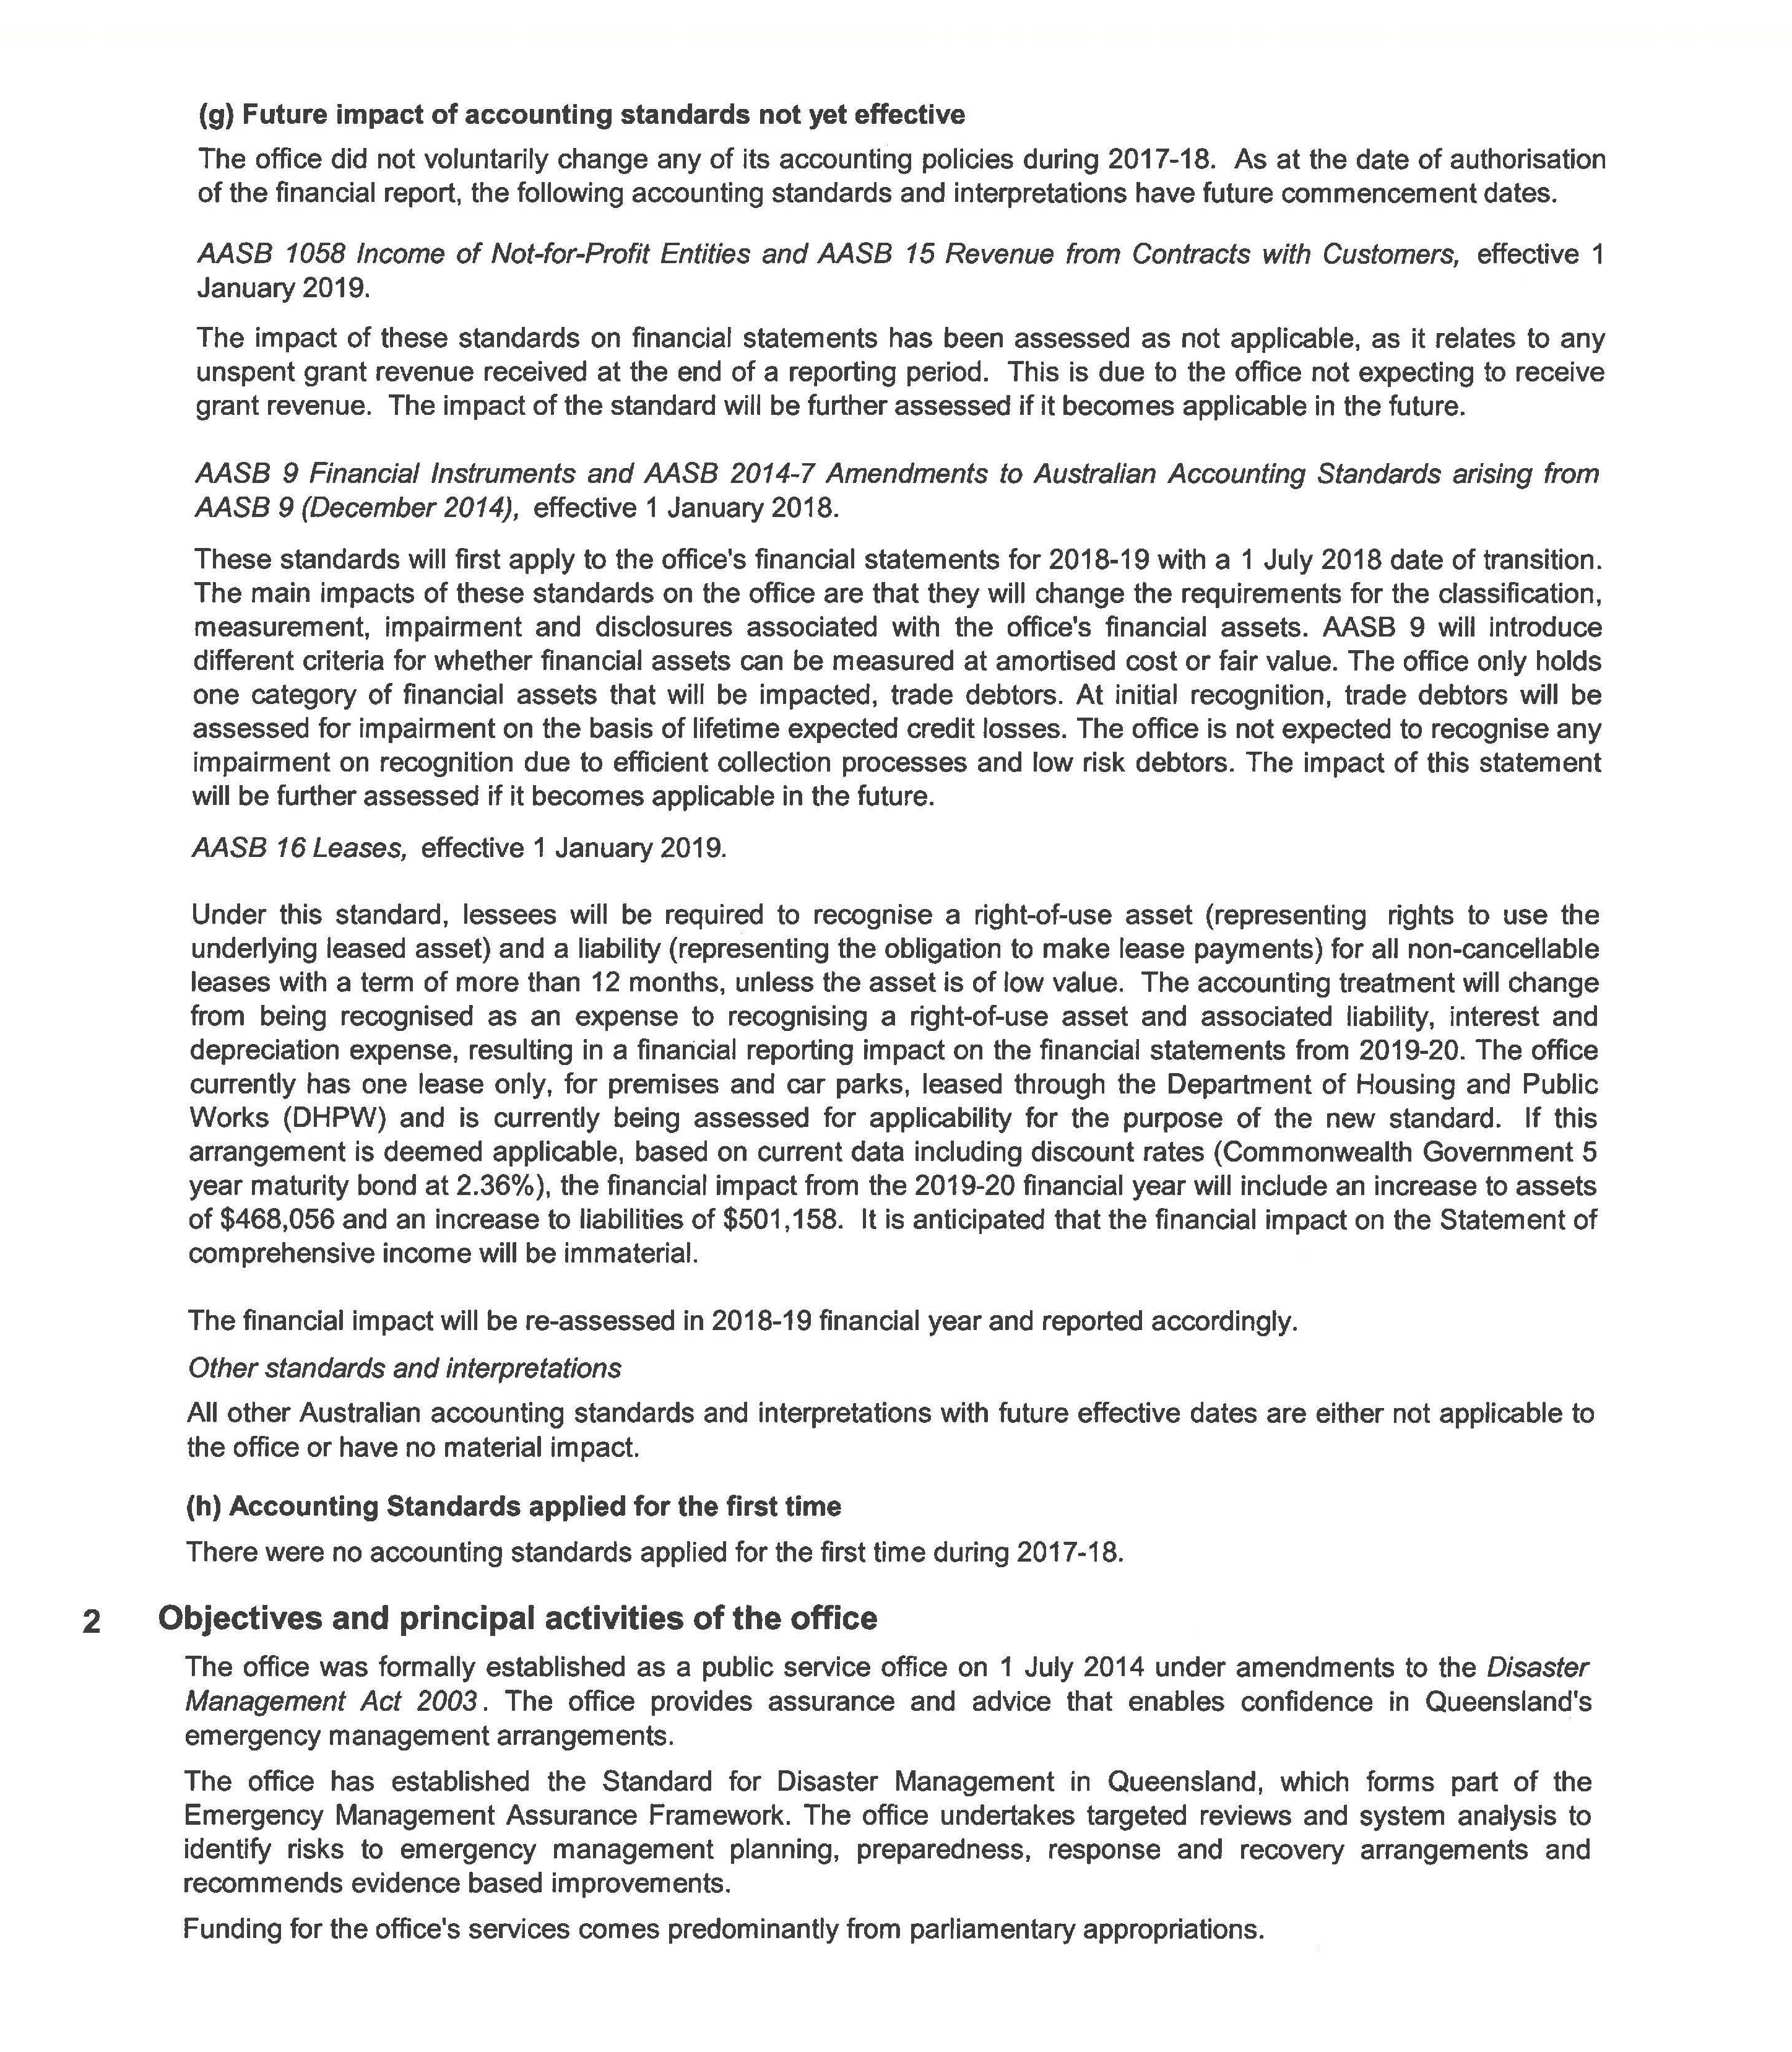

Notes to and forming part of the financial statements
2017-18 (cont’d)
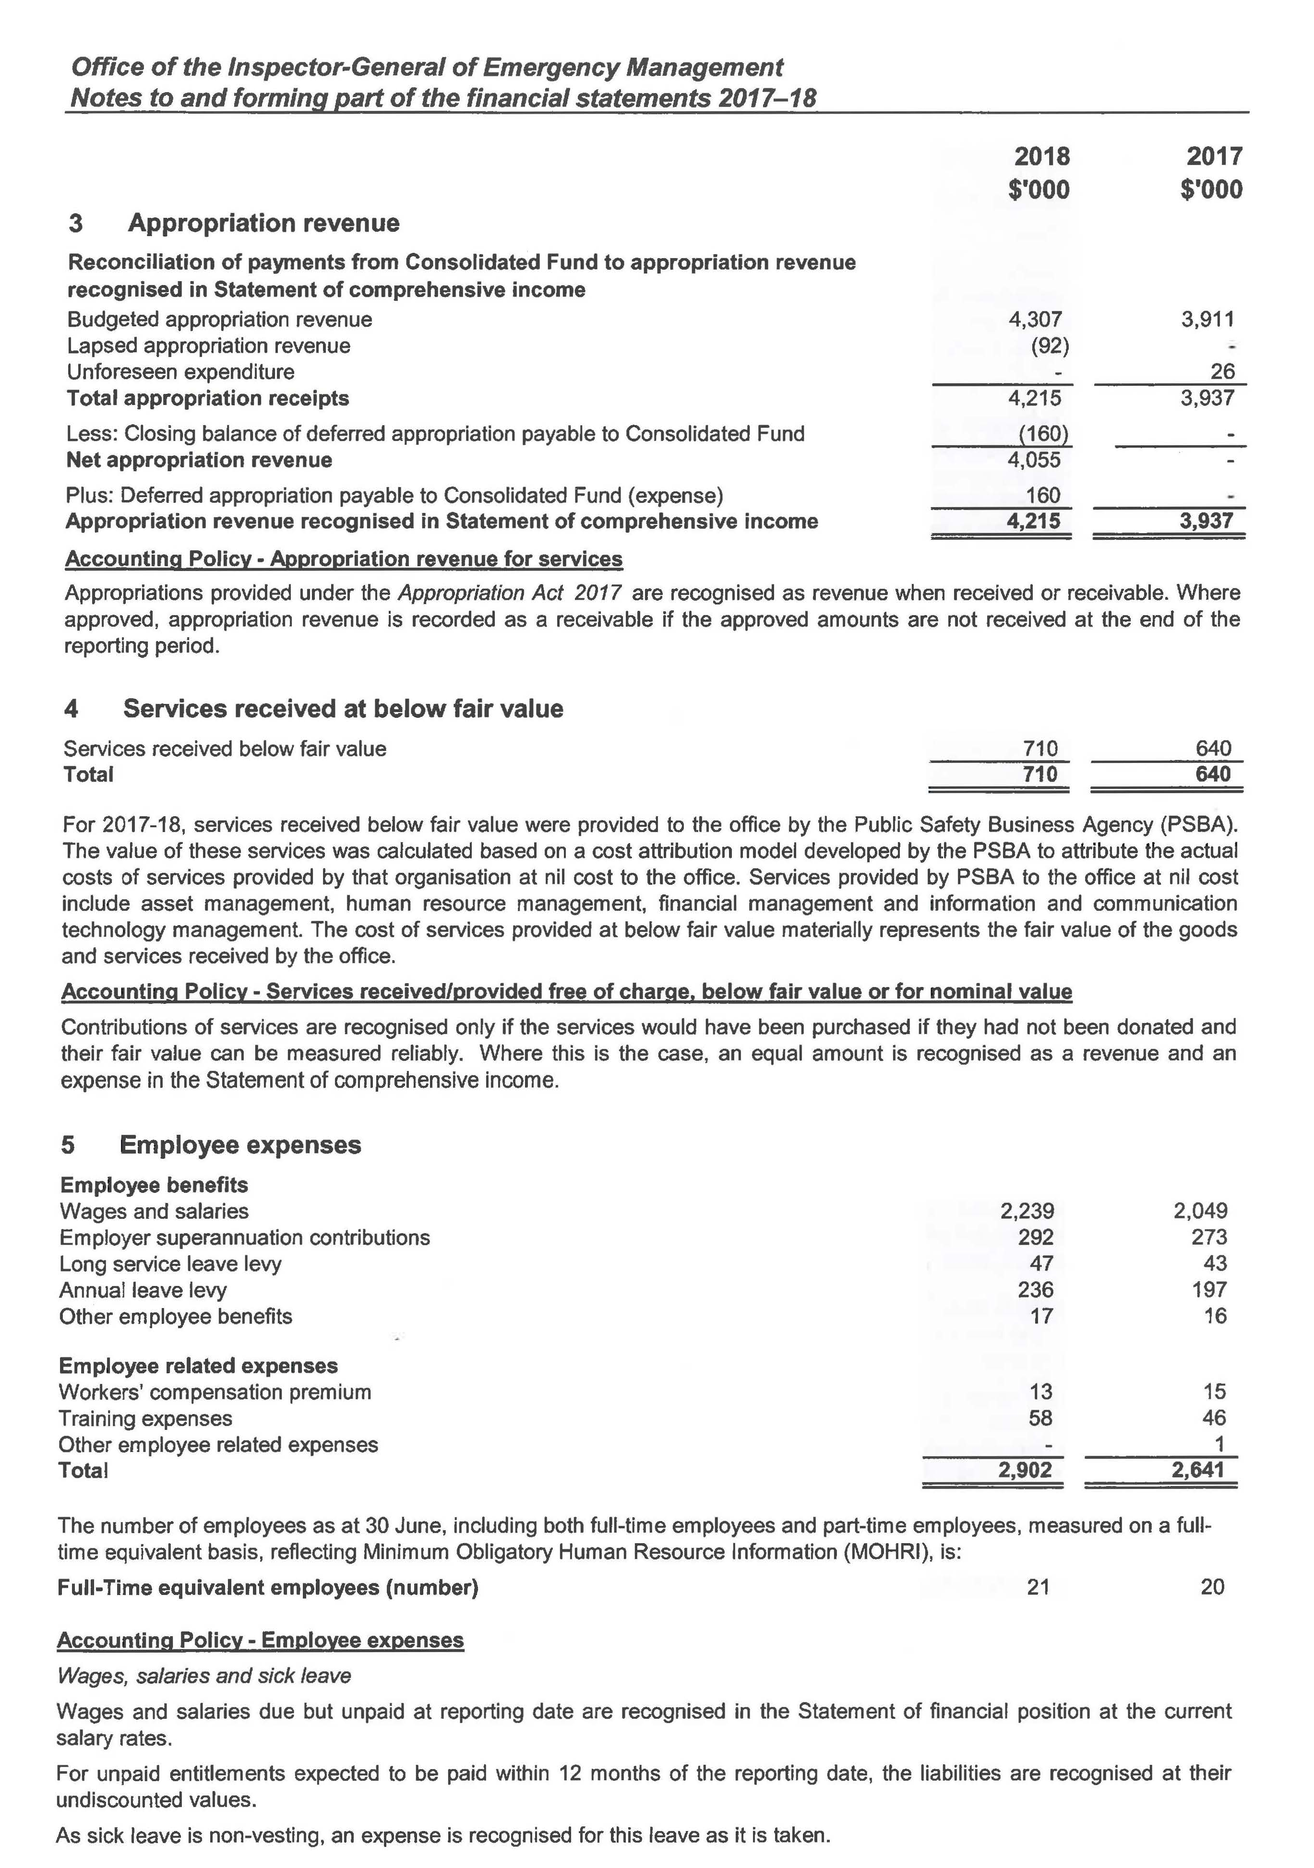

Notes to and forming part of the financial statements
2017-18 (cont’d)
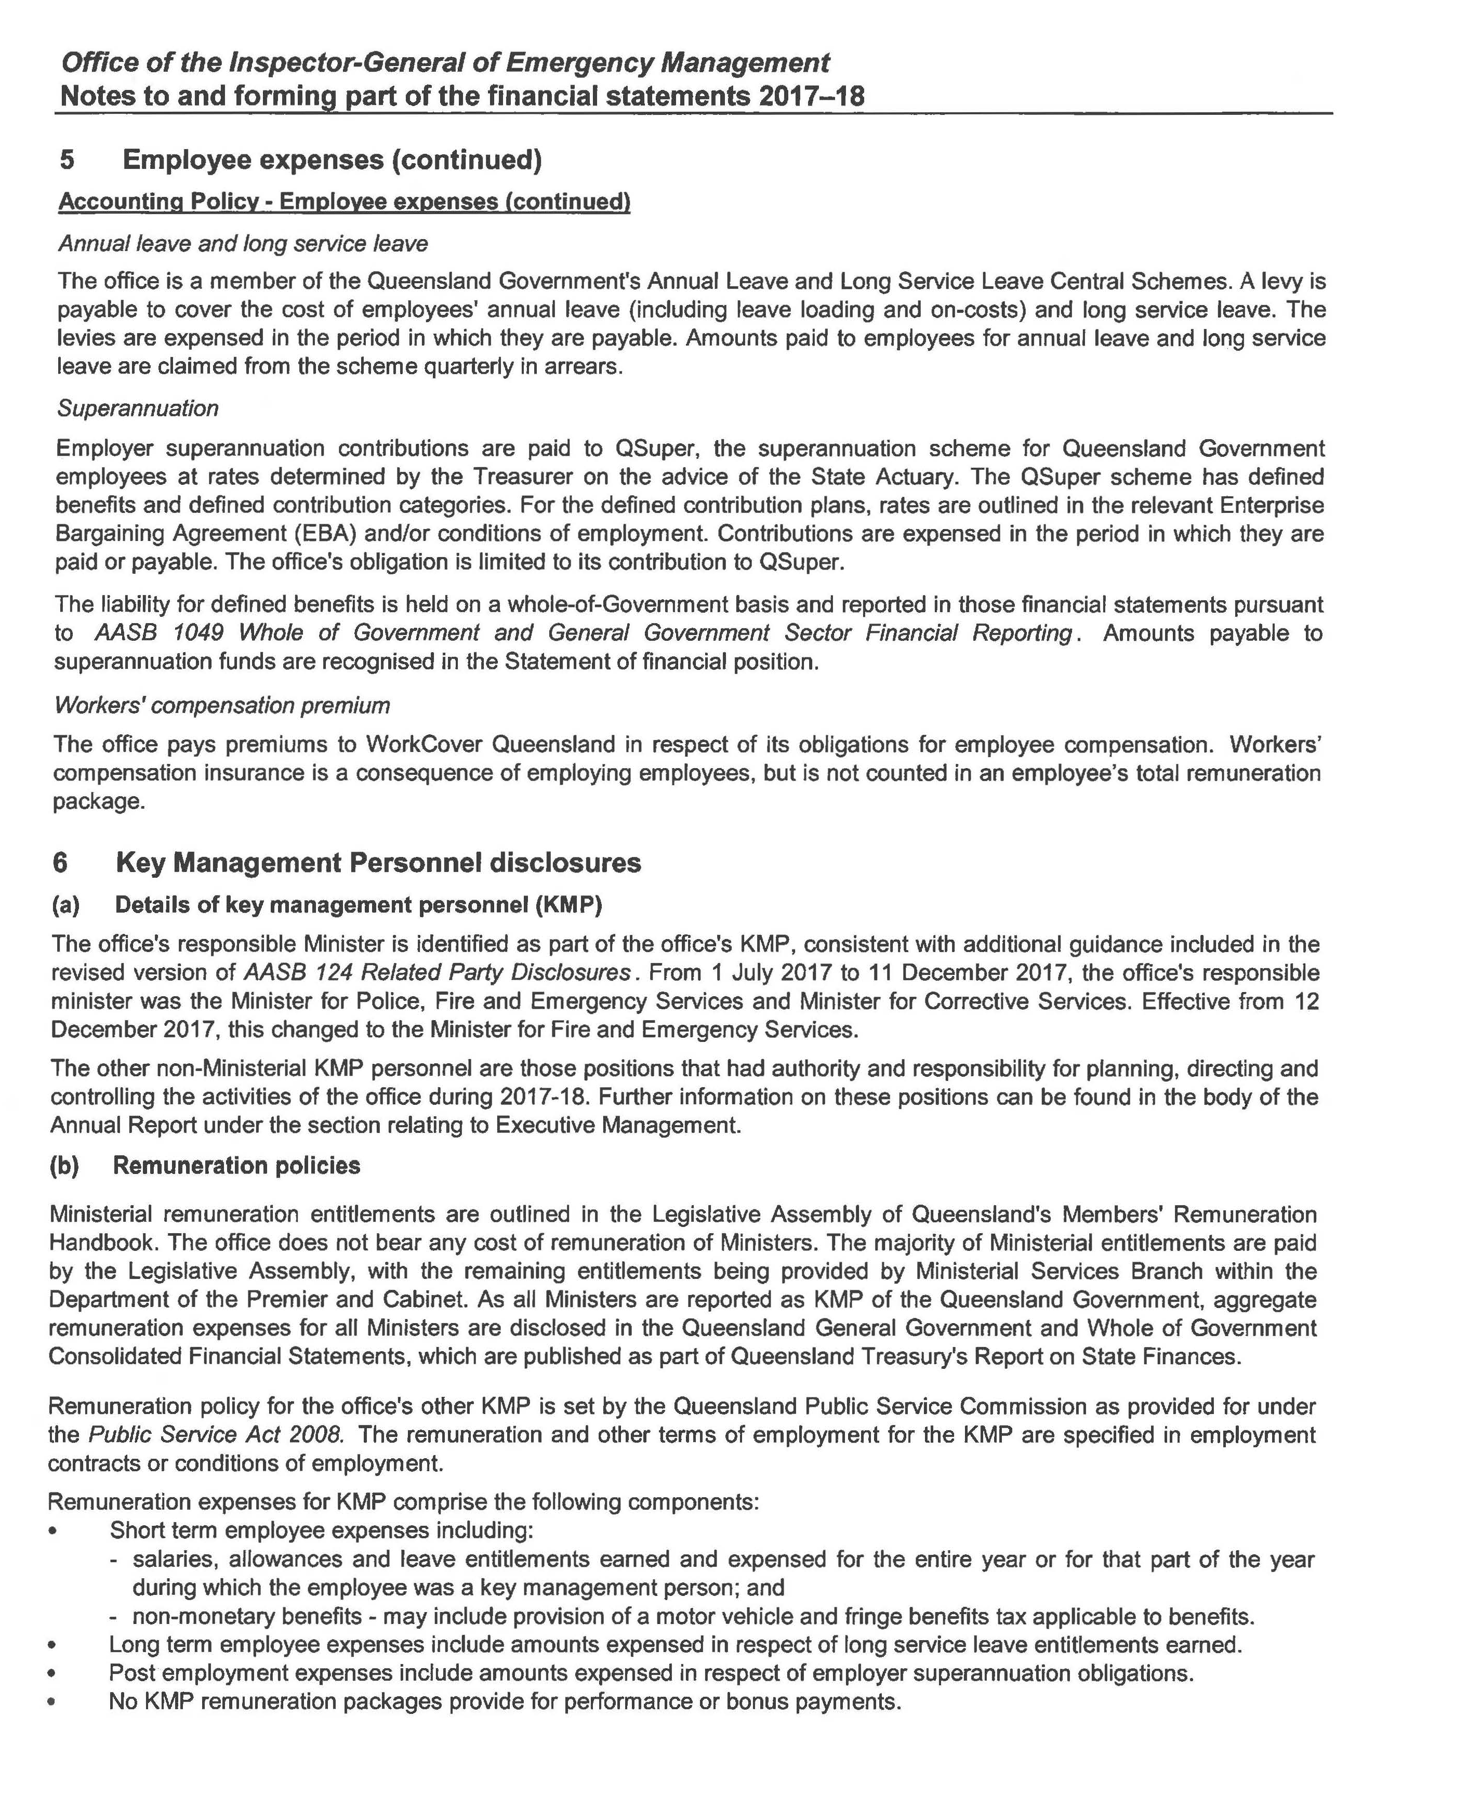

Notes to and forming part of the financial statements
2017-18 (cont’d)

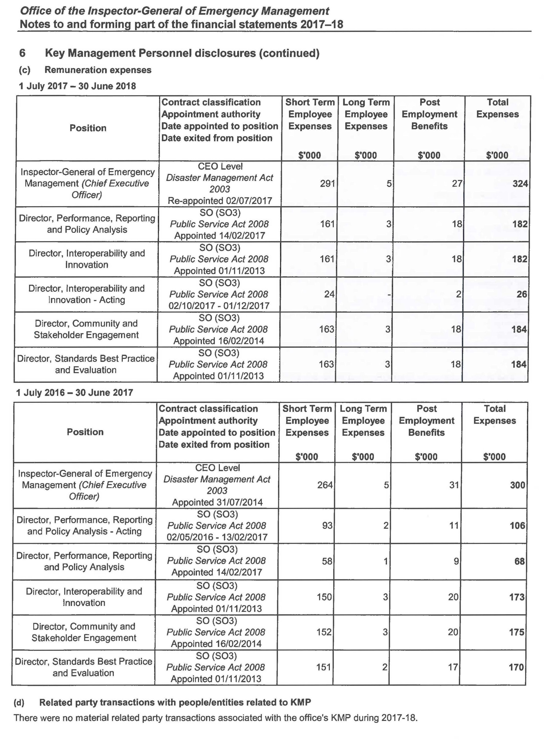

Notes to and forming part of the financial statements
2017-18 (cont’d)

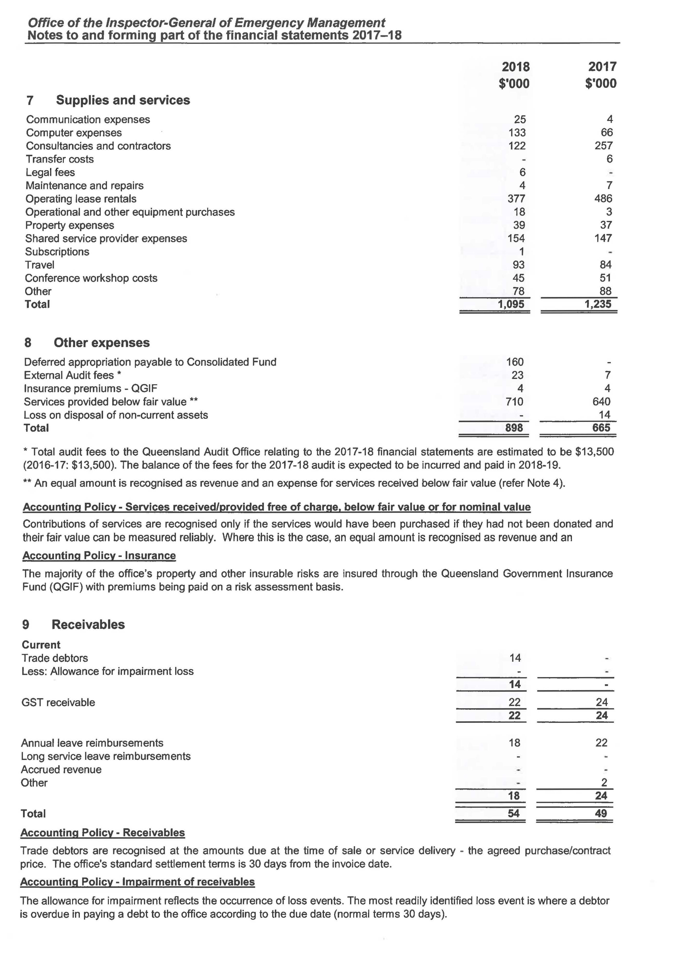

Notes to and forming part of the financial statements
2017-18 (cont’d)

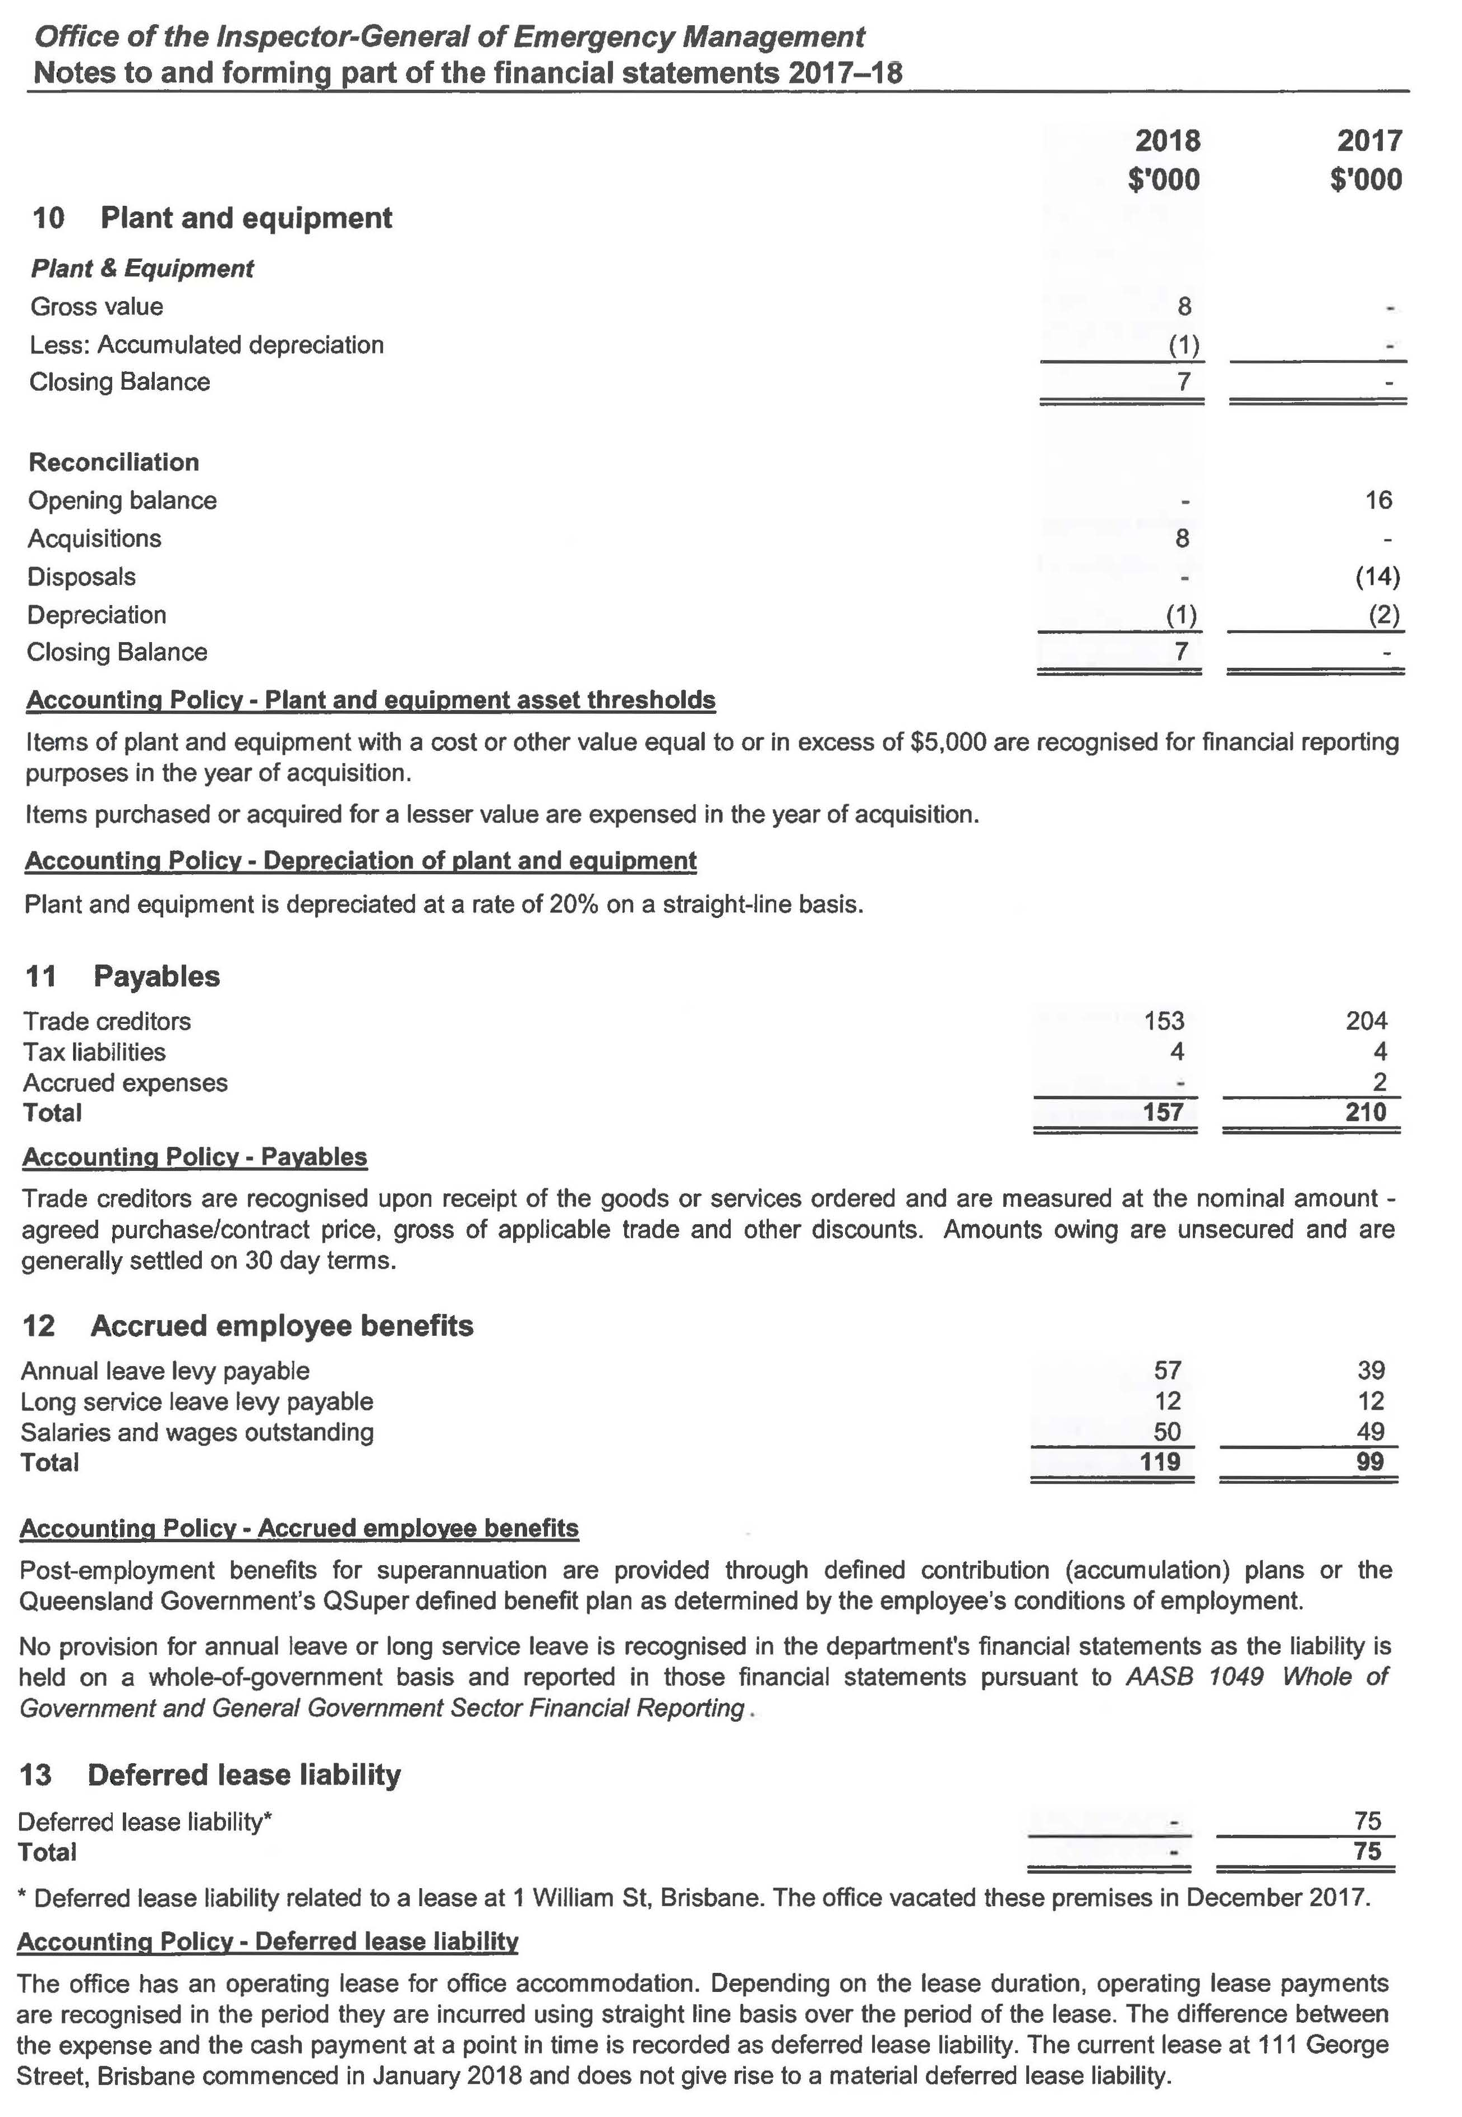

Notes to and forming part of the financial statements
2017-18 (cont’d)
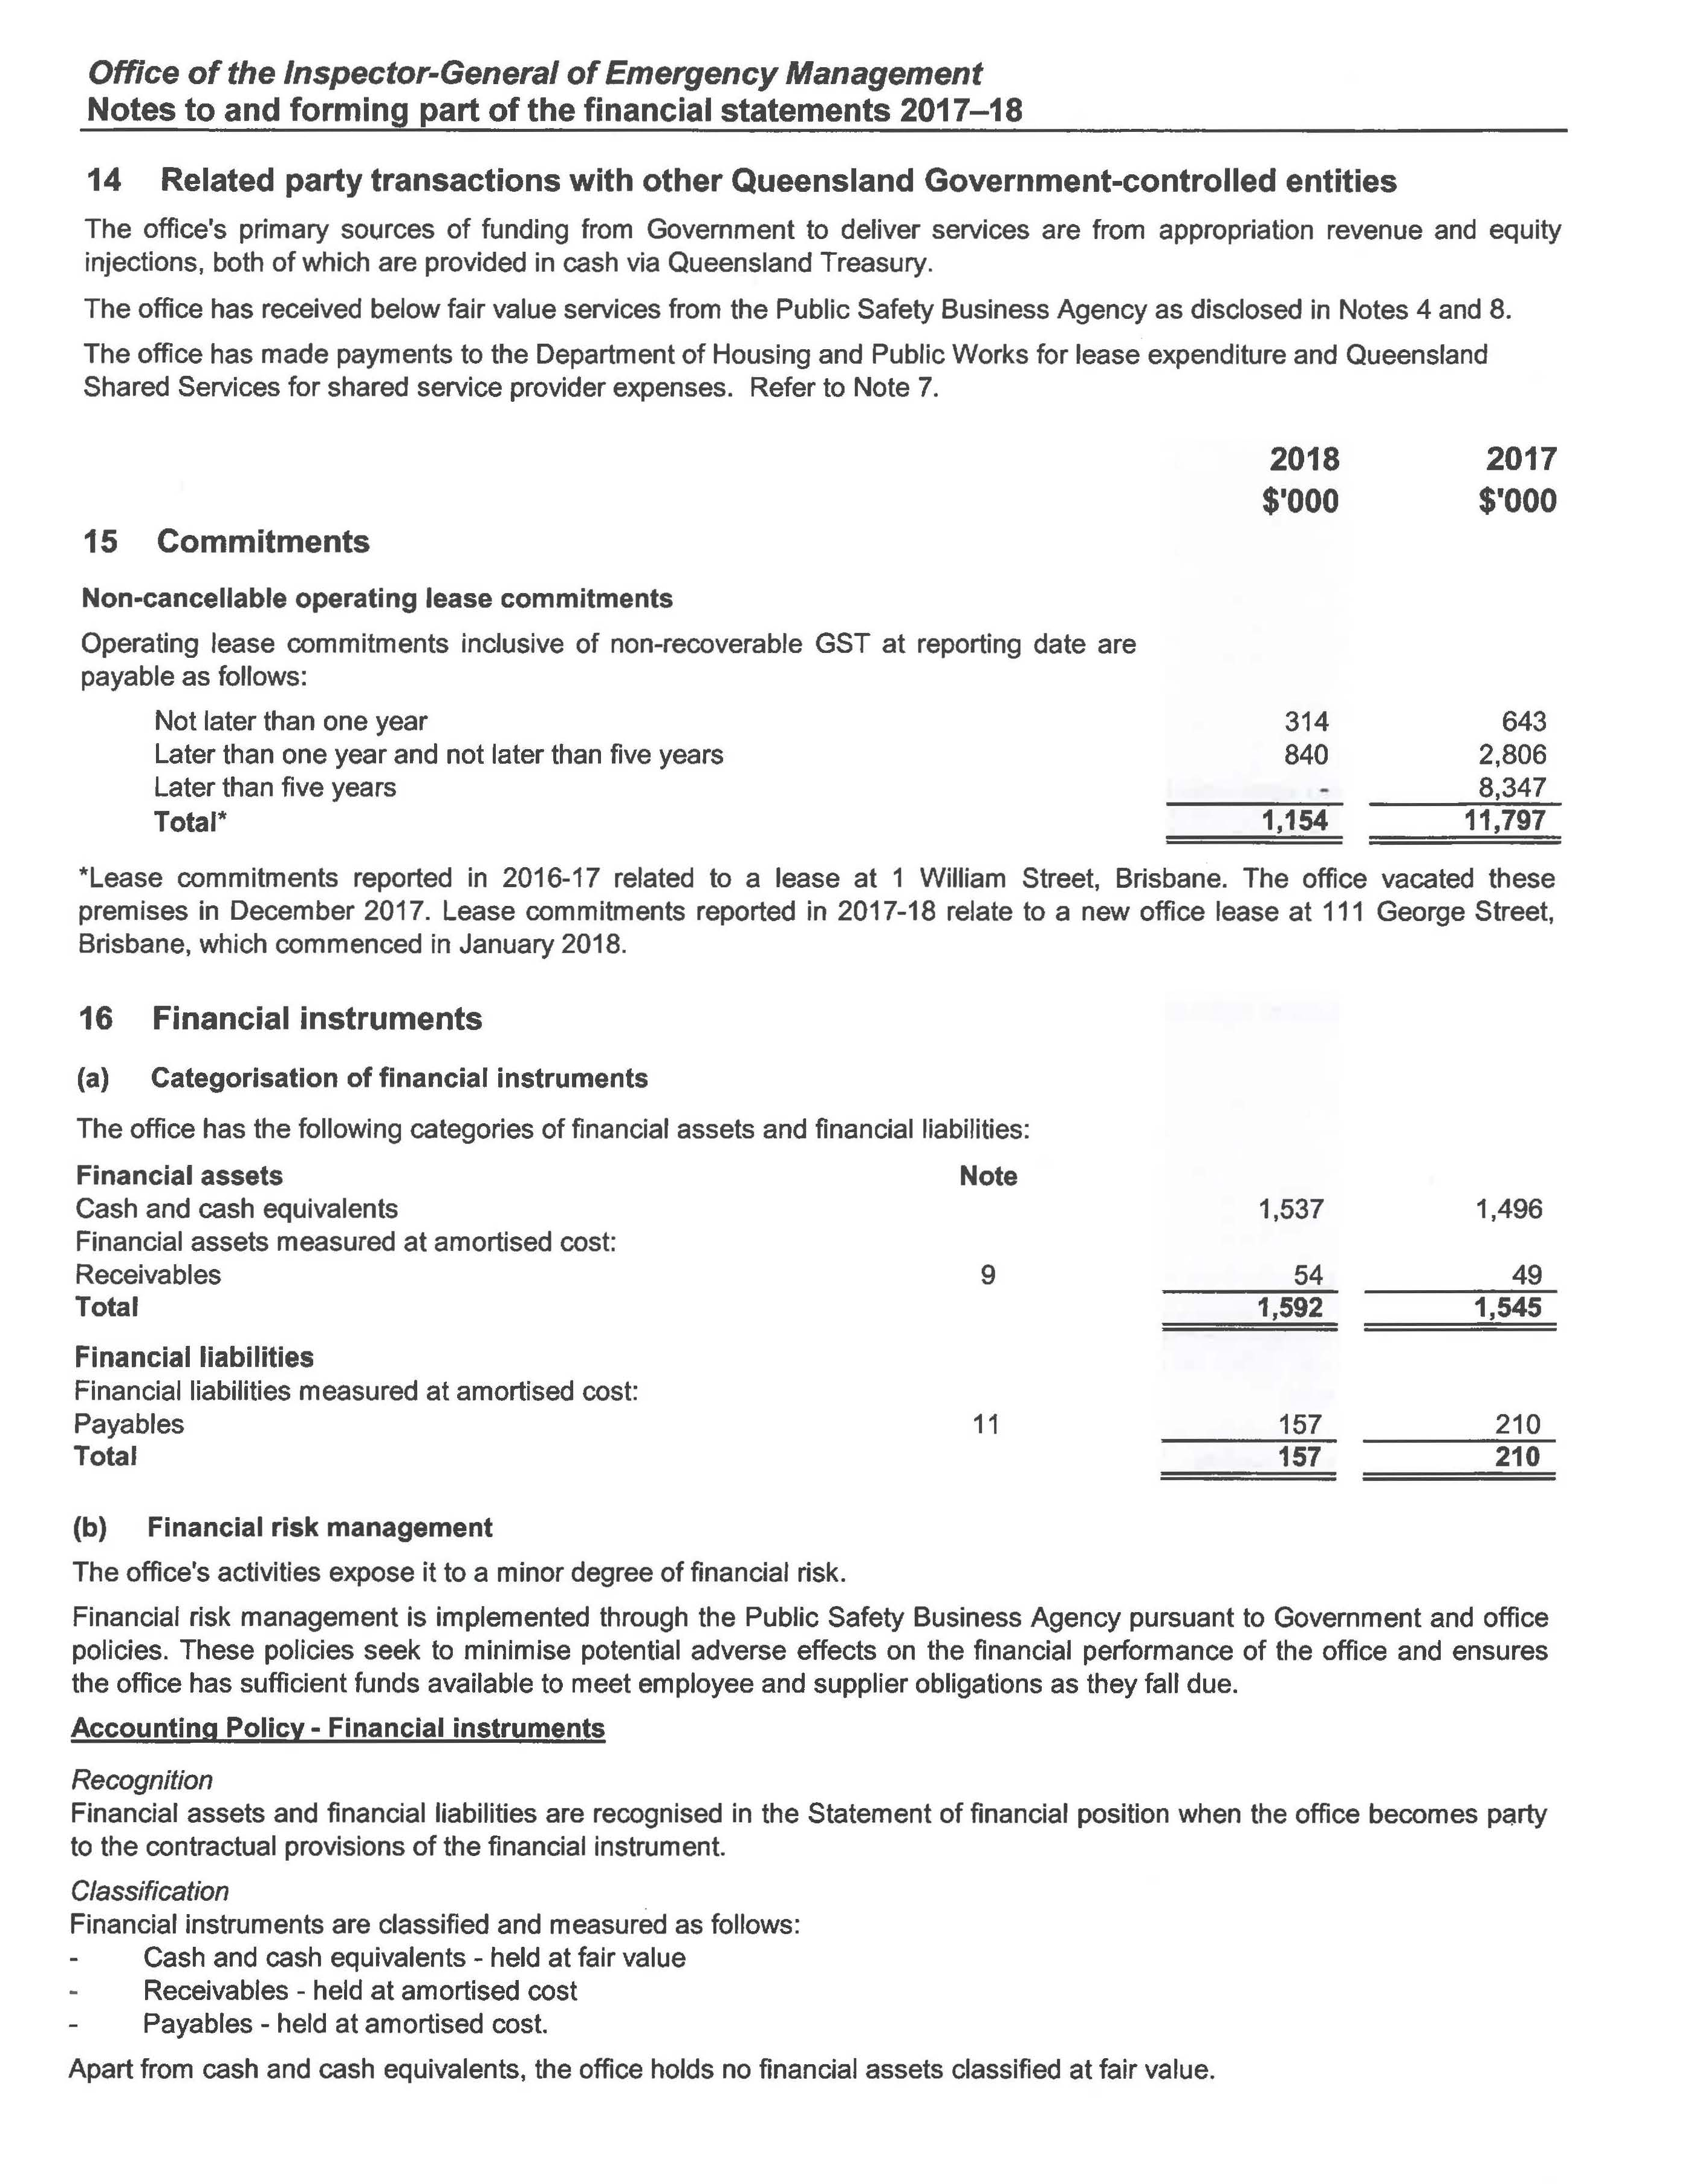

Notes to and forming part of the financial statements
2017-18 (cont’d)

Notes to and forming part of the financial statements
2017-18 (cont’d)
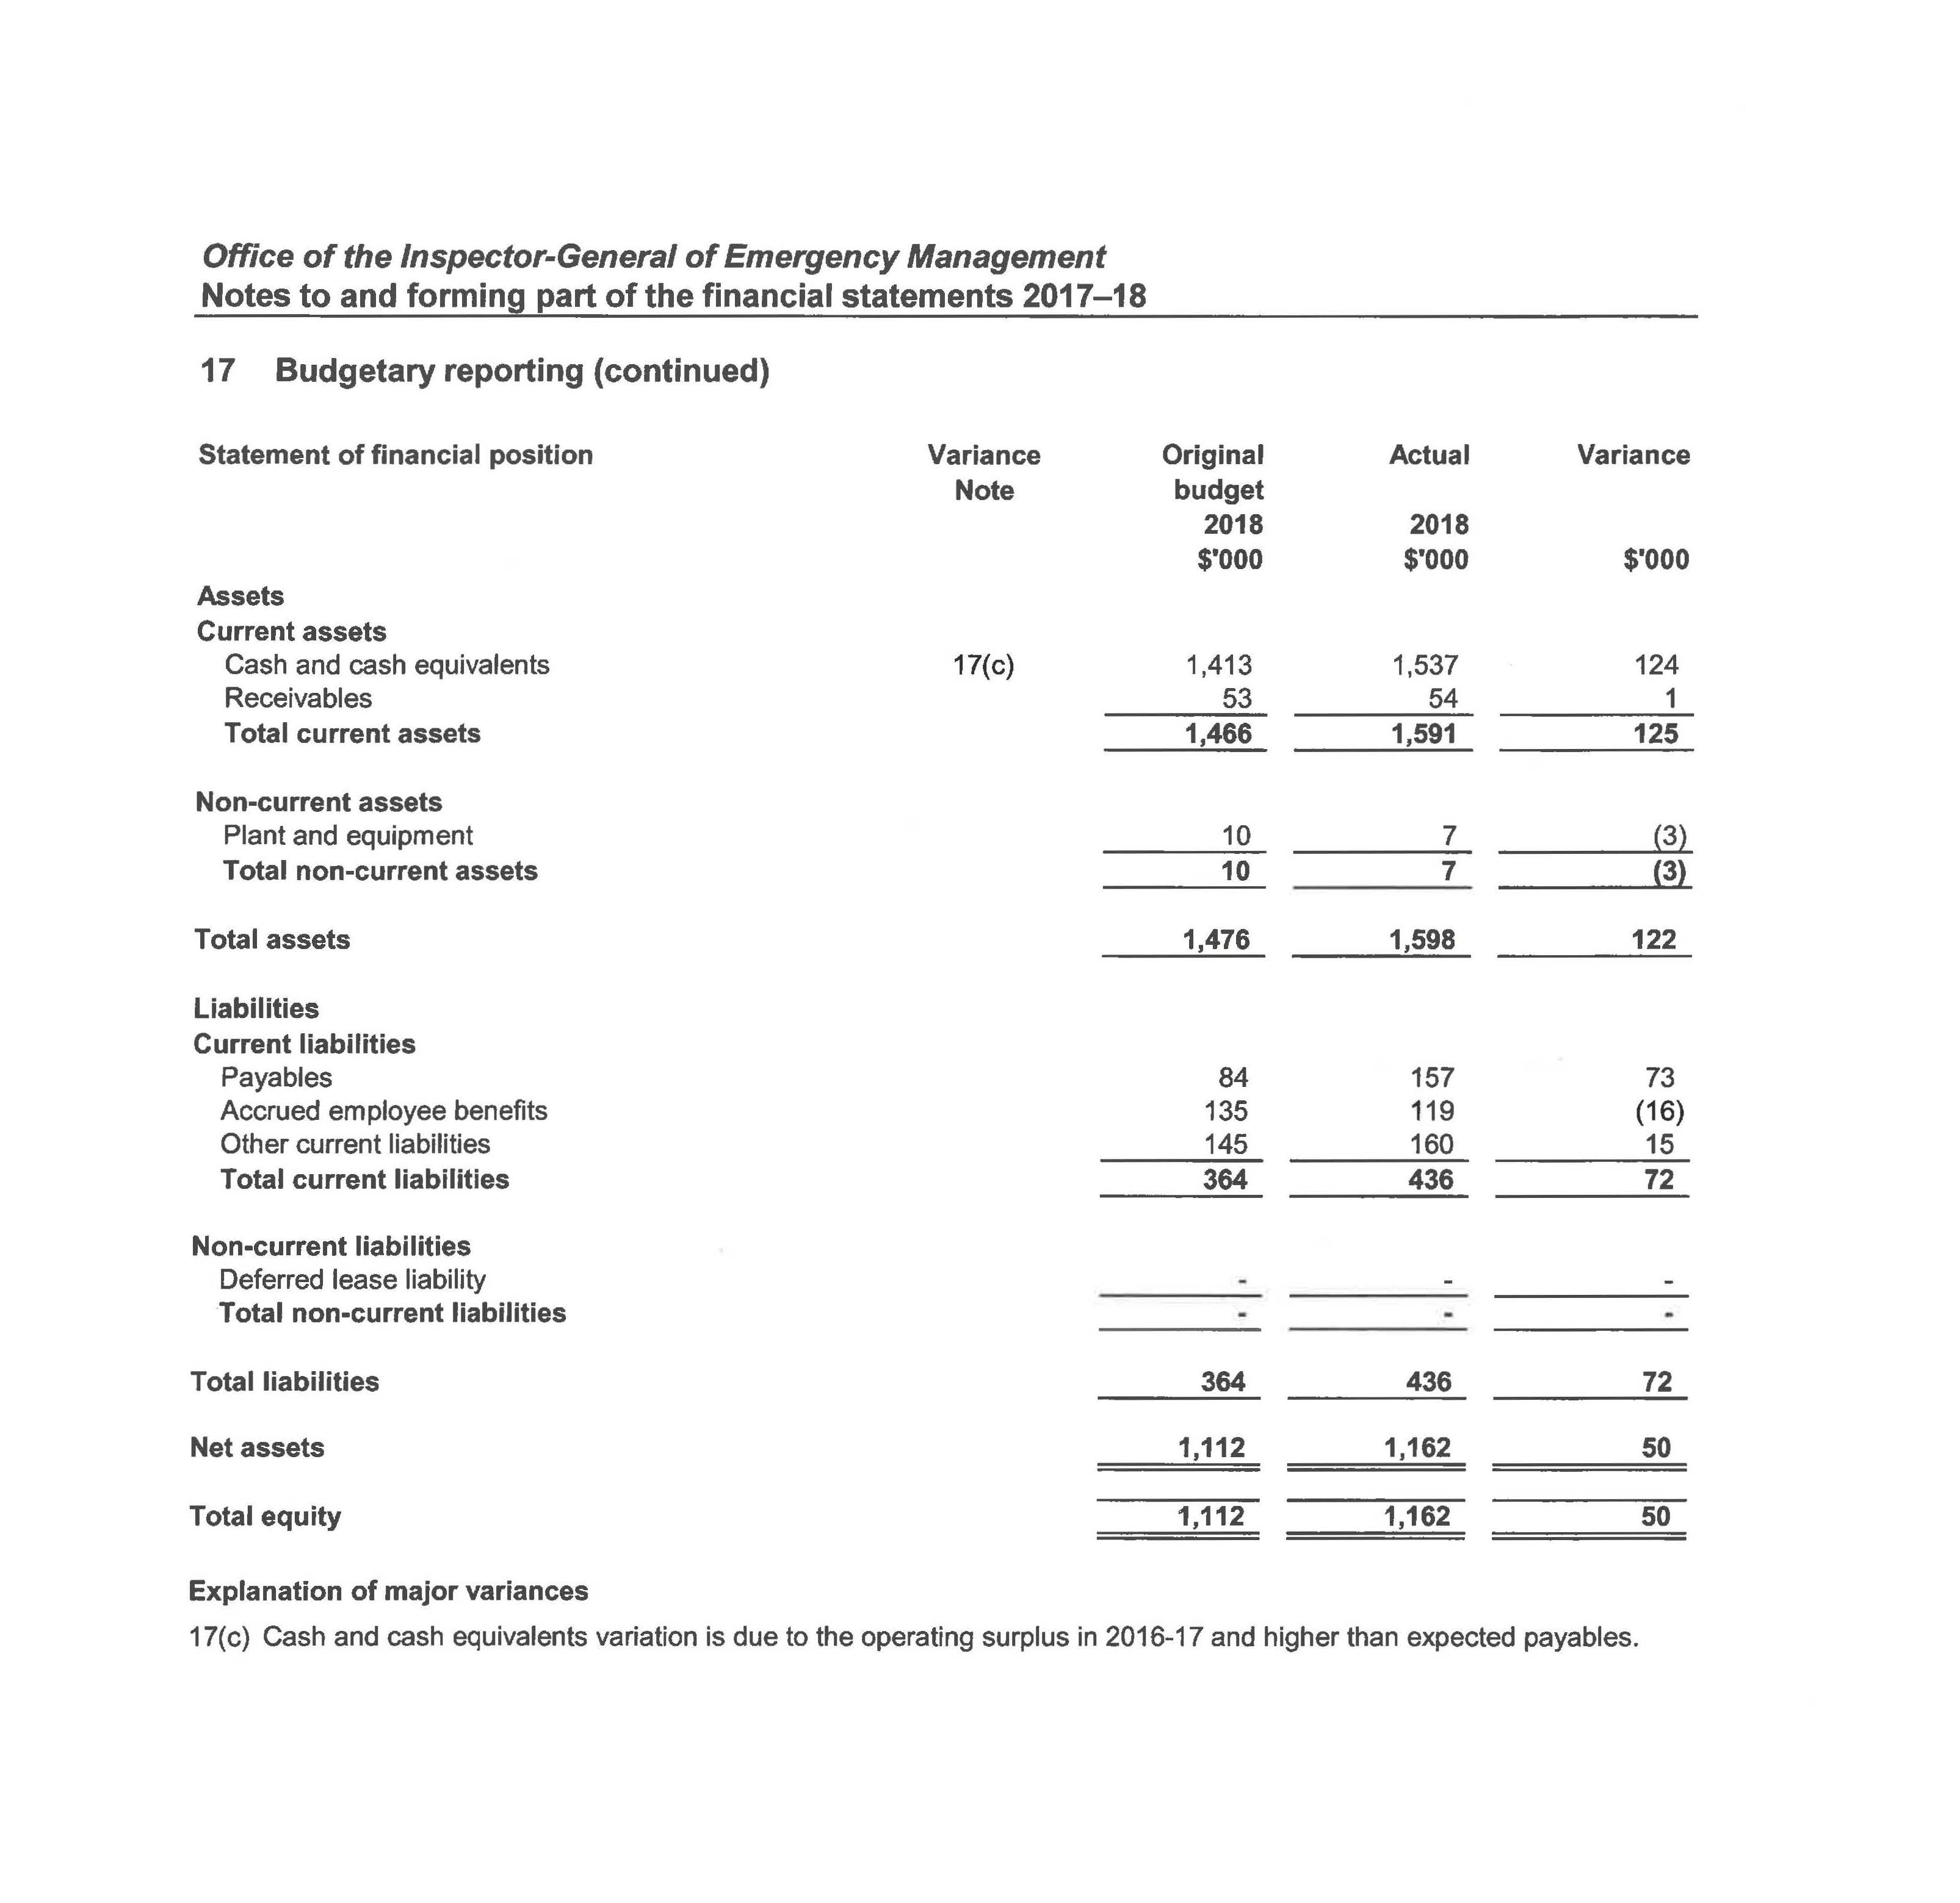

Notes to and forming part of the financial statements
2017-18 (cont’d)
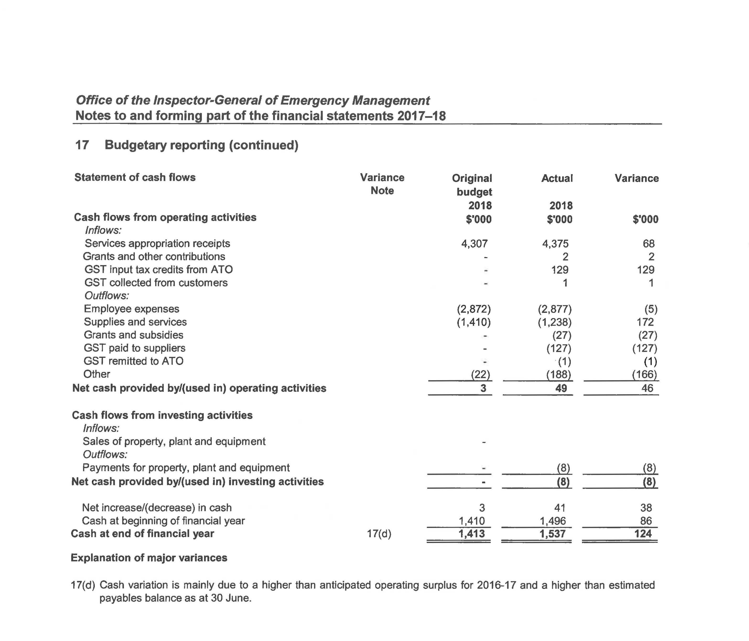

Management certificate

Independent Auditor’s report

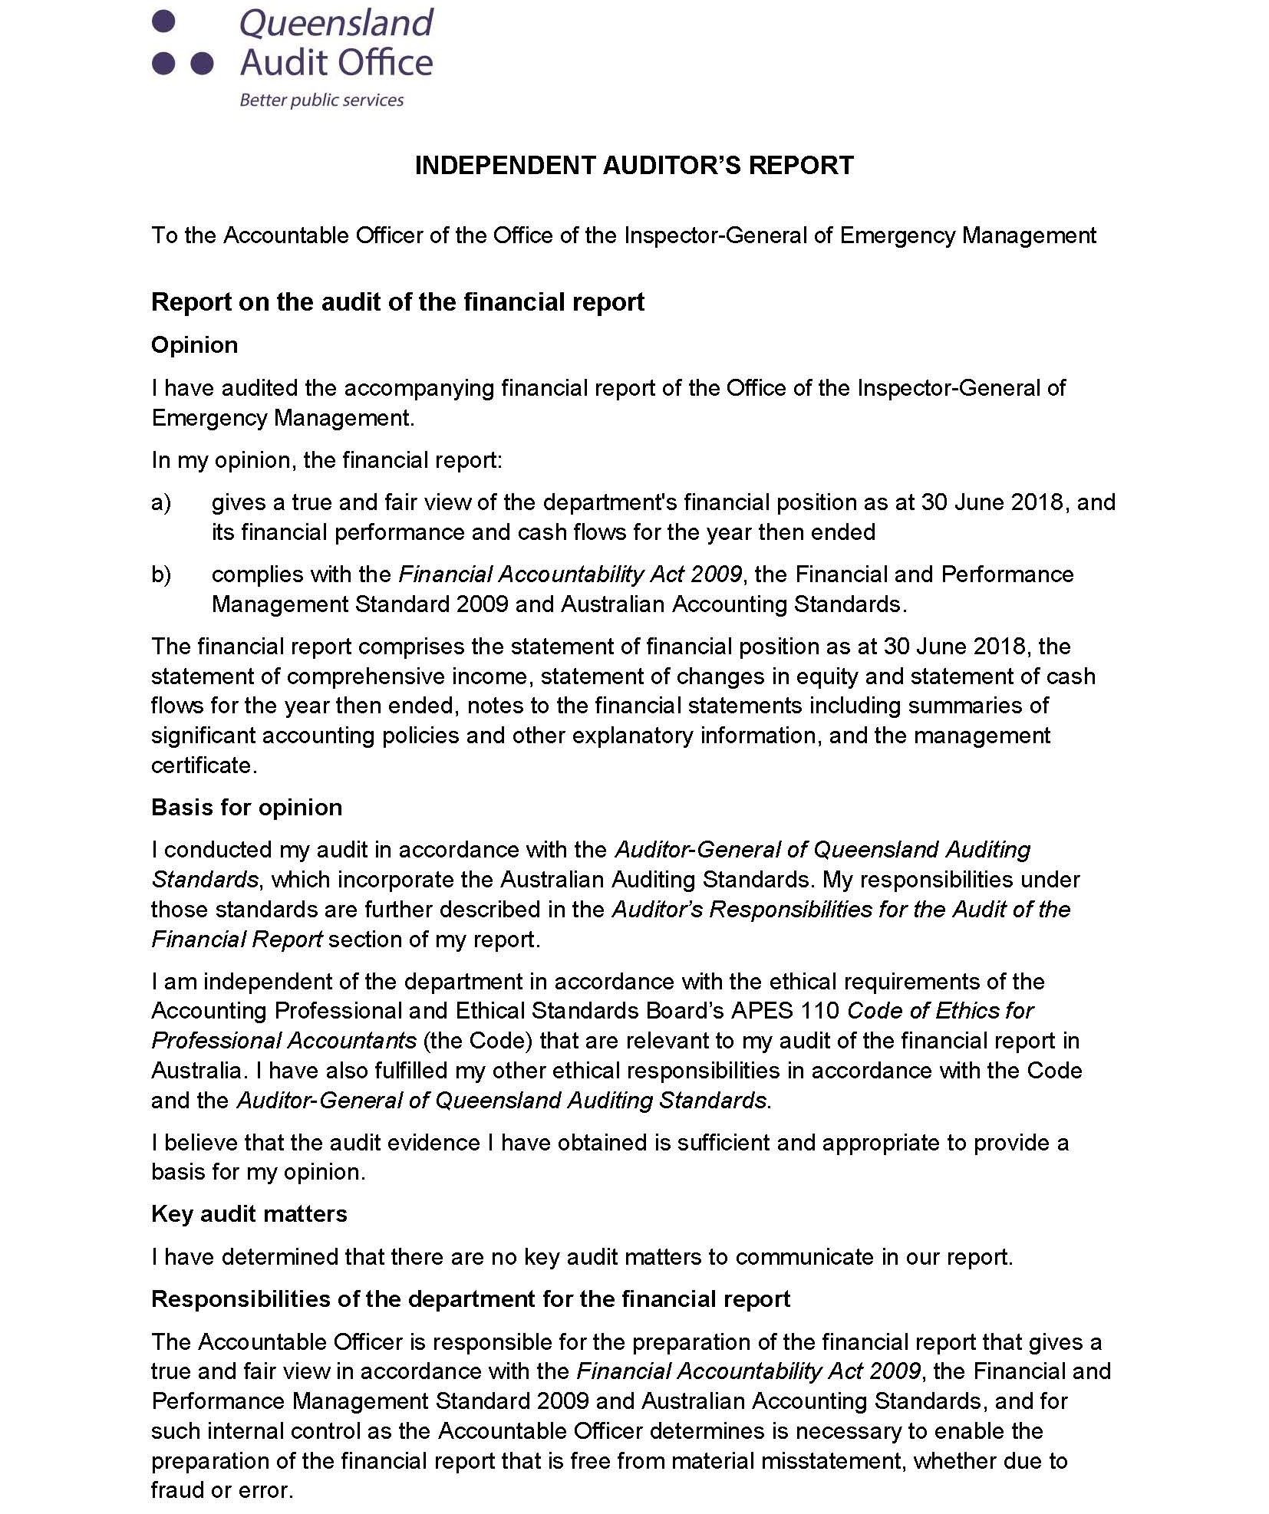

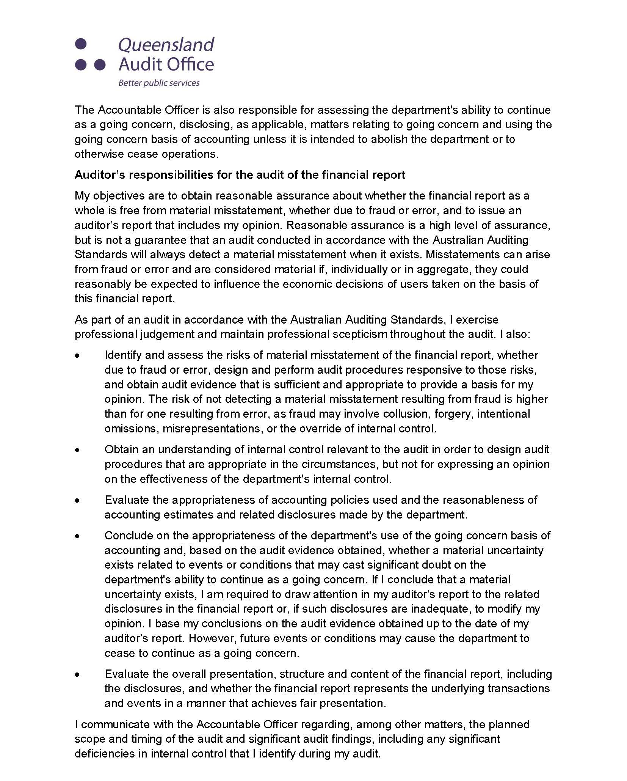
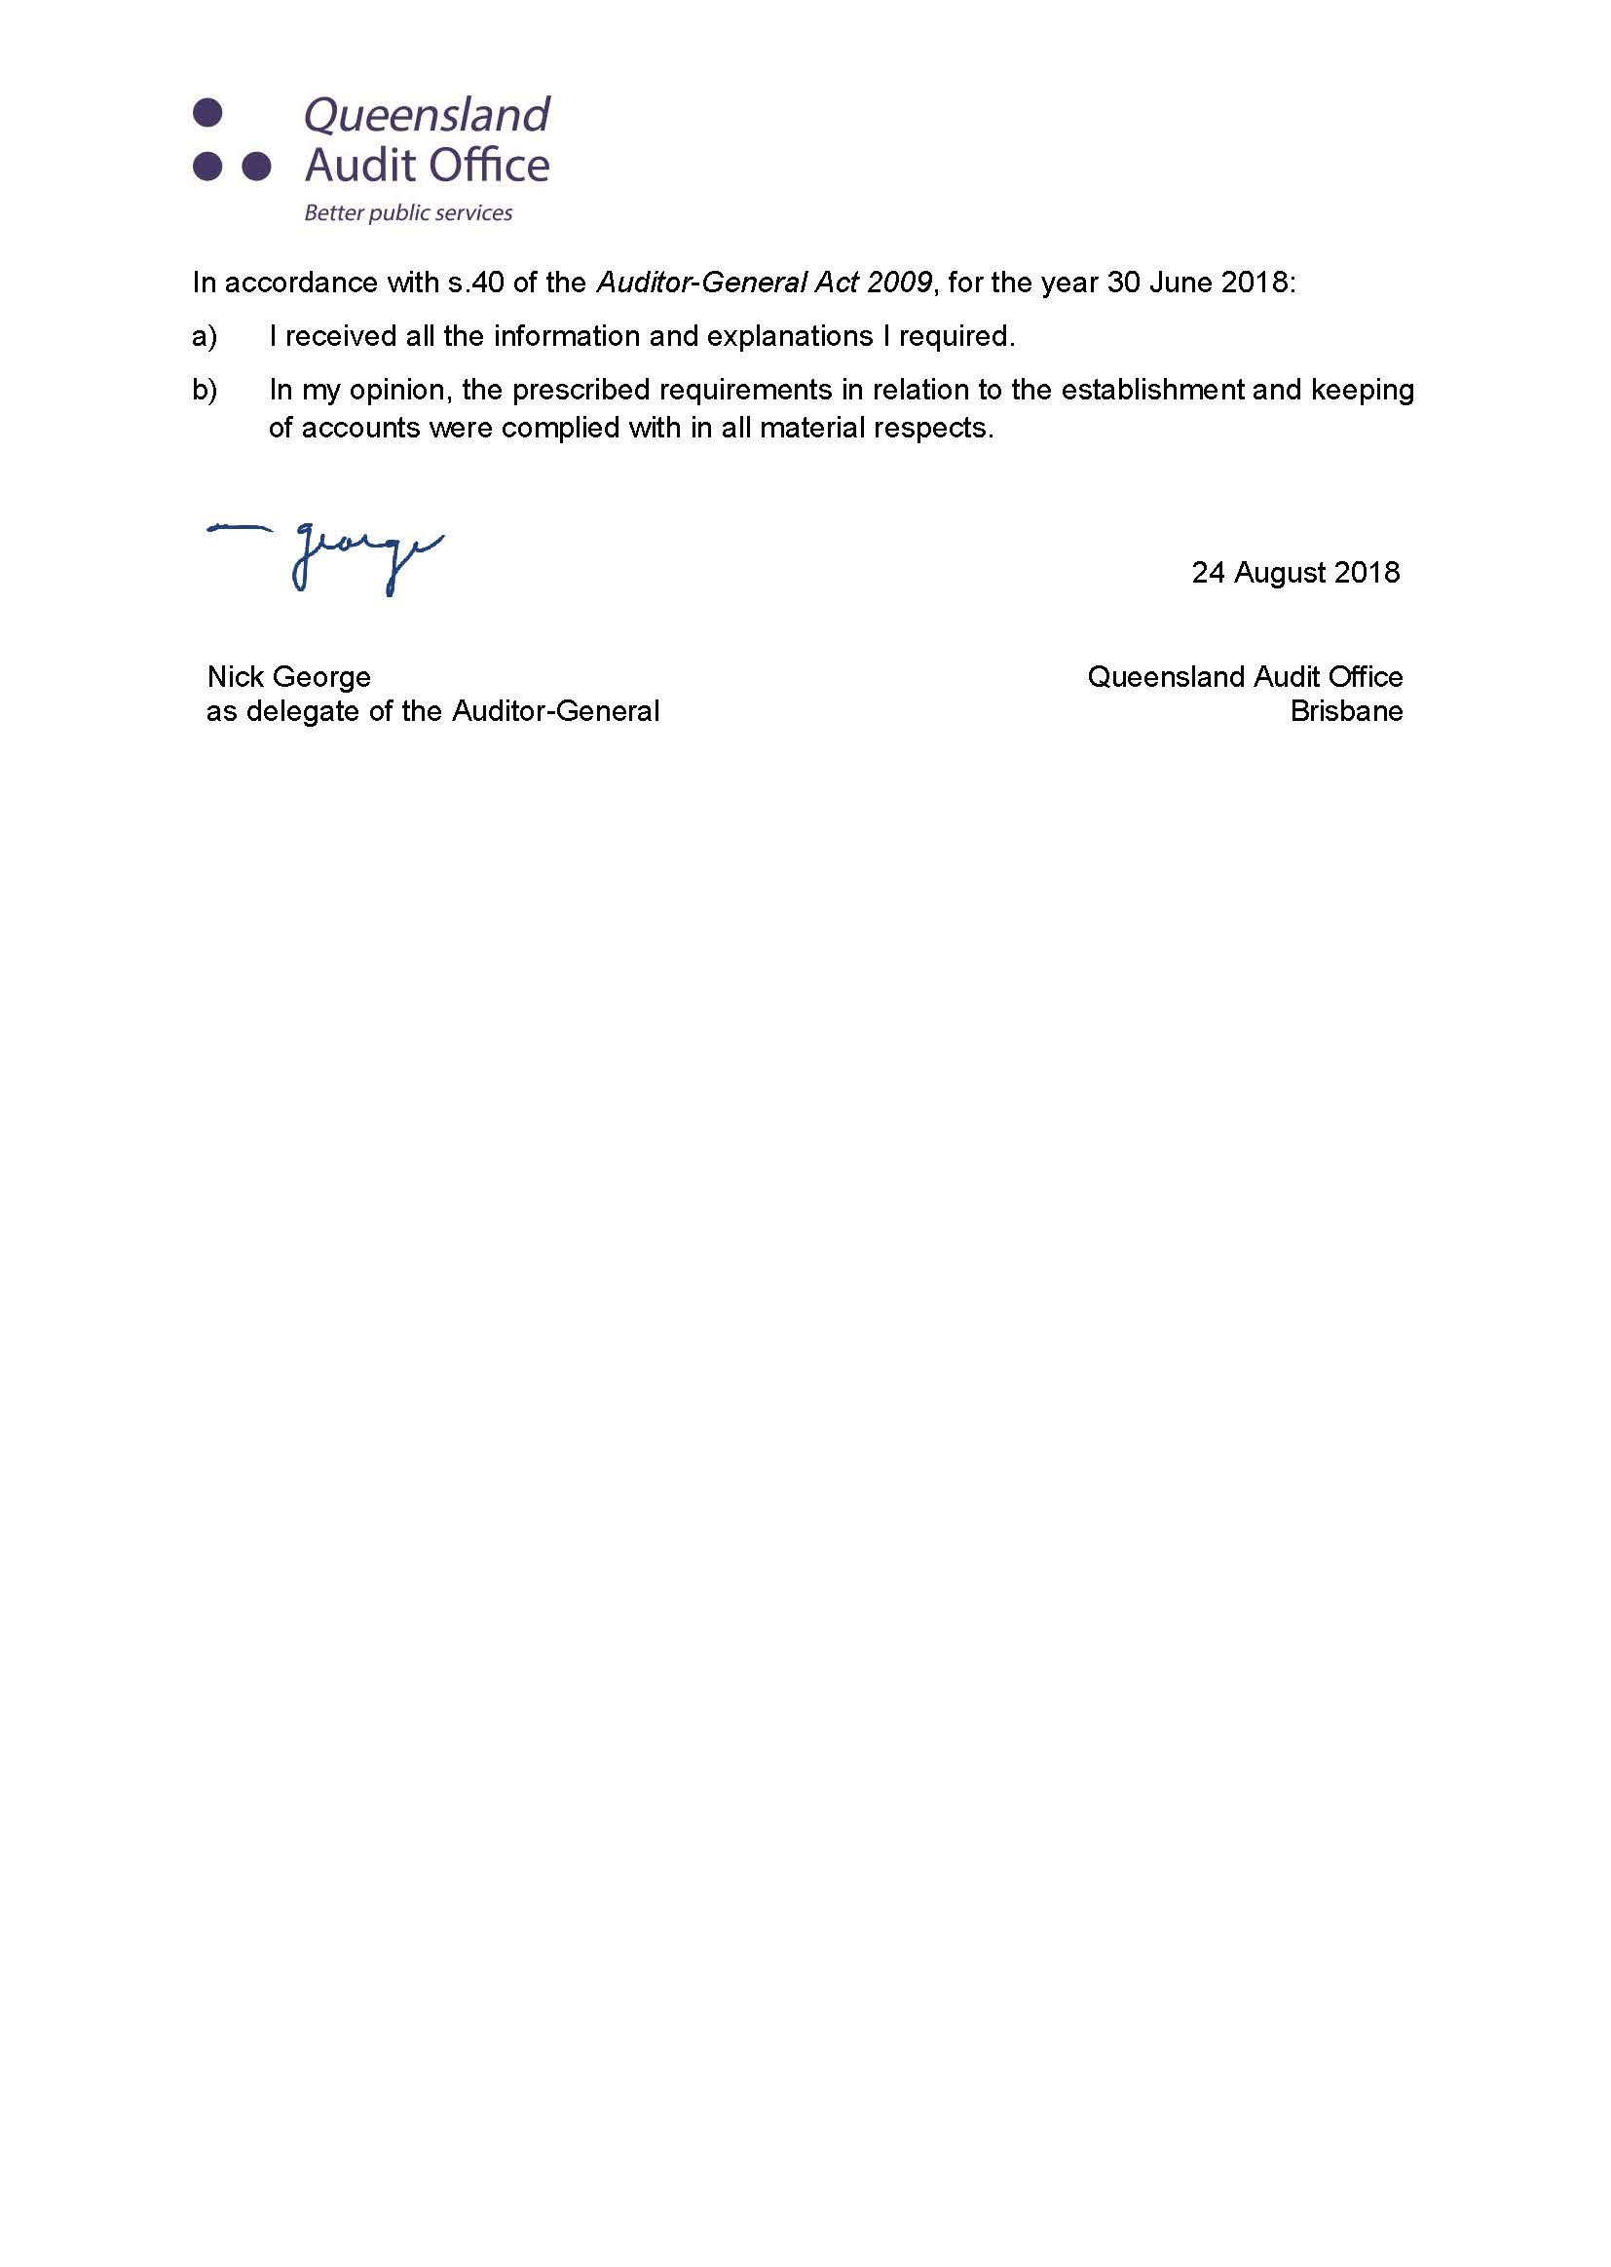

Appendices

Acronyms
AEDP | Assurance and Excellence Development Program |  | EAP | Employee Assistance Program
AFAC | Australasian Fire and Emergency Services Authorities Council |  | EMAF | Emergency Management Assurance Framework
AFSM | Australian Fire Service Medal |  | EMC | Executive Management Committee
APM | Australian Police Medal |  | FTE | Full Time Equivalent
ARC | Audit and Risk Committee |  | FPMS | Financial and Performance Management Standard 2009
ARRs | Annual report requirements for Queensland Government agencies |  | HR | Human Resources
BNHCRC | Bushfire and Natural Hazards Cooperative Research Centre |  | IGEM | Inspector-General Emergency Management
CaPE | Conduct and Performance Excellence |  | IWD | International Womens Day
CCC | Crime and Corruption Commission |  | LGAQ | Local Government Association of Queensland
COTA | Council on the Ageing |  | MBE | Member of the British Empire
DATSIP | Department of Aboriginal and Torres Strait Islander Partnerships |  | MOU | Memorandum of Understanding
DCDSS | Department of Comunities, Disability Services and Seniors |  | PDP | Performance and Development Planning
DFV | Domestic and Family Violence |  | PSBA | Public Safety Business Agency
DHPW | Department of Housing and Public Works |  | QAO | Queensland Audit Office
DLGRMA | Department of Local Government, Racing and Multicultural Affairs |  | QDMC | Queensland Disaster Management Committee
DMO | Disaster Management Officer |  | QFES | Queensland Fire and Emergency Services
DPC | Department of the Premier and Cabinet |  | QH | Queensland Health
DTMR | Department of Transport and Main Roads |  | QPS | Queensland Police Service

QRA | Queensland Reconstruction Authority |  | SDCG | State Disaster Coordination Group
QUT | Queensland University of Technology |  | TWiG | Testing Within Government

Compliance checklist
Summary of requirement |  | Basis for requirement | Annual report reference
Letter of compliance | - A letter of compliance from the accountable officer or statutory body to the relevant Minister/s | ARRs – section 7 | ii
Accessibility | - Table of contents  - Acronyms | ARRs – section 9.1 | 1  55-56
 | - Public availability | ARRs – section 9.2 | i
 | - Interpreter service statement | Queensland Government Language Services Policy  ARRs – section 9.3 | i
 | - Copyright notice | Copyright Act 1968  ARRs – section 9.4 | i
 | - Information Licensing | Queensland Government Enterprise Architecture – Information Licensing  ARRs – section 9.5 | i
General information | - Introductory information | ARRs – section 10.1 | 4-9
 | - Machinery-of-government changes | ARRs – section 31 and 32 | Not applicable
 | - Agency role and main functions | ARRs – section 10.2 | 4-9
 | - Operating environment | ARRs – section 10.3 | 5-8
Non-financial performance | - Government’s objectives for the community | ARRs – section 11.1 | 5
 | - Other whole-of-government plans/specific initiatives | ARRs – section 11.2 | 14-23
 | - Agency objectives and performance indicators | ARRs – section 11.3 | 14-23
 | - Agency service areas and service standards | ARRs – section 11.4 | 12-13
Financial performance | - Summary of financial performance | ARRs – section 12.1 | 10-11
Governance – management and structure | - Organisational structure | ARRs – section 13.1 | 9
 | - Executive management | ARRs – section 13.2 | 26-27
 | - Government bodies (statutory bodies and other entities) | ARRs – section 13.3 | Not applicable
 | - Public Sector Ethics Act 1994 | Public Sector Ethics Act 1994  ARRs – section 13.4 | 28
 | - Queensland public service values | ARRs – section 13.5 | 6
Governance – risk management and accountability | - Risk management | ARRs – section 14.1 | 27, 29-31
 | - Audit committee | ARRs – section 14.2 | 27
 | - Internal audit | ARRs – section 14.3 | 30-31
 | - External scrutiny | ARRs – section 14.4 | 29-30
 | - Information systems and recordkeeping | ARRs – section 14.5 | 31
Governance – human resources | - Strategic workforce planning and performance | ARRs – section 15.1 | 32-34
 | - Early retirement, redundancy and retrenchment | Directive No.16/16 Early Retirement, Redundancy and Retrenchment (from 20 May 2016 – 10 May 2018)  Directive No.4/18 Early Retirement, Redundancy and Retrenchment (from 11 May 2018)  ARRs – section 15.2 | 34
Open Data | - Statement advising publication of information | ARRs – section 16 | i
 | - Consultancies | ARRs – section 33.1 | i
 | - Overseas travel | ARRs – section 33.2 | i
 | - Queensland Language Services Policy | ARRs – section 33.3 | i
Financial statements | - Certification of financial statements | Financial Accountability Act 2009 – section 62  Financial and Performance Management Standard 2009 – sections 42, 43 and 50  ARRs – section 17.1 | 51
 | - Independent Auditor’s Report | Financial Accountability Act 2009 – section 62  Financial and Performance Management Standard 2009 – section 50  ARRs – section 17.2 | 52-54

Contacts and key locations

Head office
Level 26
111 George Street
Brisbane Qld 4000

Mailing address
GPO Box 1425
Mail Cluster 15.7
Brisbane Qld 4001

Telephone
(07) 3029 8813

